Product Goal
The overarching goal of Rebound is to transform how athletes and coaches at the amateur and semi-professional levels document, track, and showcase their sports journeys through a powerful and user-friendly mobile platform. The application is designed to introduce structure, visibility, and professional-grade tools to individuals and teams that are often underserved by conventional sports technology solutions, particularly at the grassroots level.
Rebound addresses the widespread challenge faced by athletes and coaches who lack a centralized and reliable system to record match performances, monitor progress over time, and build credible sports portfolios for future opportunities. The platform enables athletes to log both individual and team-based performance statistics—such as points, assists, rebounds, fouls, and other key metrics—while providing coaches with tools to validate game data, manage teams, and evaluate player development.
Beyond basic statistics tracking, Rebound aims to deliver a comprehensive digital ecosystem for sports performance management. Users can analyze trends through visual timelines and graphs, share game-related updates through posts, and maintain a searchable and verifiable record of their sporting history. This record functions as a dynamic digital portfolio that athletes can leverage when applying to clubs, seeking sponsorships, or showcasing their talent to scouts and recruiters.
From an innovation perspective, Rebound aims to:
- Provide professional-level analytics and structured documentation for non-professional athletes.
- Ensure data transparency and authenticity through coach-approved game logs.
- Support long-term athlete development through consistent performance tracking and feedback mechanisms.
- Encourage community engagement through profile discovery and post creation features.
By achieving these objectives, Rebound empowers athletes and coaches to take ownership of their development, gain recognition for their efforts, and bridge the gap between grassroots talent and professional opportunities. The product is driven by the need to innovate within an overlooked segment of the sports industry and to provide equitable access to performance-tracking tools.

1.6 Product Backlog
The product backlog of Rebound consists of user stories that define the core functionalities of the application from the perspective of athletes and coaches.
S. No. | User Story ID | User Story Description
1 | US-01 | As a new user, I want to register as a coach or an athlete so that I can access platform features such as profile creation and game documentation.
2 | US-02 | As a new user, I want to set up my athlete profile (name, position, experience, etc.) so that I can personalize my account.
3 | US-03 | As a new user, I want to add my team to my profile so that I can manage team-related data.
4 | US-04 | As an athlete, I want to log a new game so that I can track my performance and statistics.
5 | US-05 | As a coach, I want to approve game logs submitted by athletes so that the data is verified and accurate.
6 | US-06 | As an athlete, I want to view my game logs in a chronological timeline to track my progress over time.
7 | US-07 | As an athlete, I want to visualize my performance statistics (points, rebounds, assists, etc.) using graphs and charts for better analysis.
8 | US-08 | As a coach, I want to create and manage a team so that I can oversee players and their performance data.
9 | US-09 | As an athlete, I want to create posts to share my achievements, thoughts, and statistics with my followers.
10 | US-10 | As a user, I want to view other athletes and teams so that I can stay informed about their progress and achievements.
11 | US-11 | As an athlete, I want a personalized dashboard displaying key performance indicators (such as points per game, rebounds per game, and shooting percentage) to easily monitor my improvement.
1.1. Each user story includes MoSCoW prioritization, functional and non-functional requirements, detailed acceptance criteria, and linked development tasks.

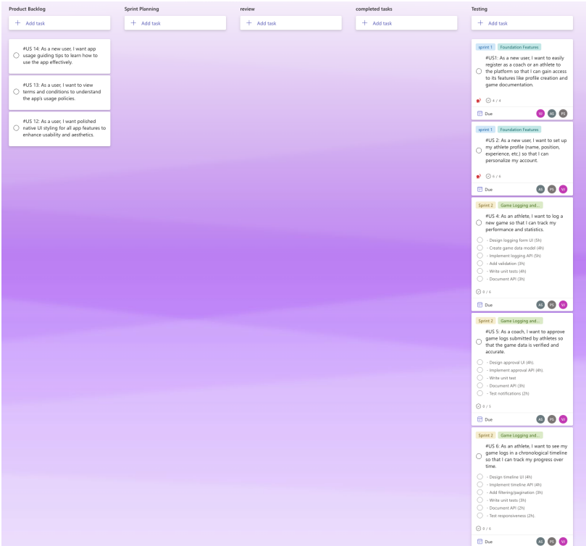Figure 1.1 MS Planner Board of Rebound

1.7 Product Release Plan
The release plan for the Rebound application outlines the phased delivery of features across multiple iterations. It ensures incremental development, continuous validation, and timely deployment of core functionalities.
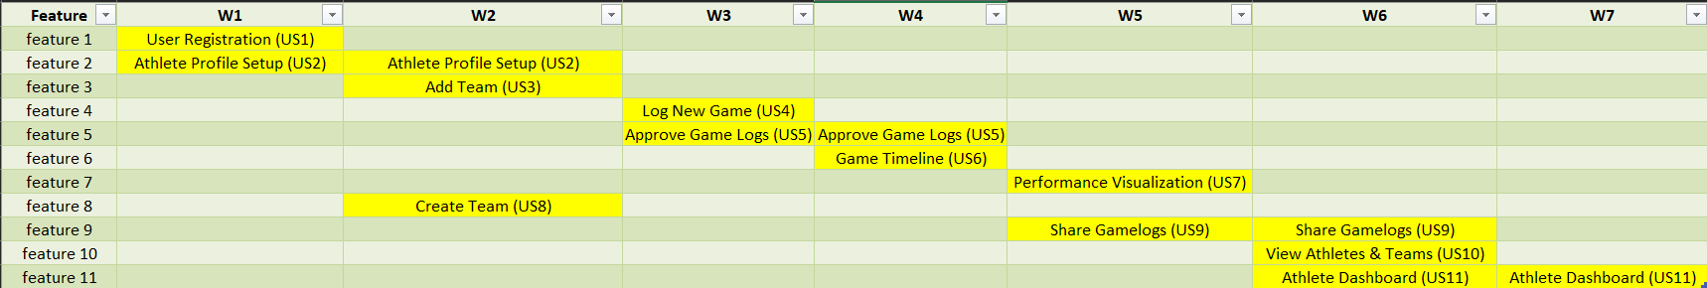
Figure 1.2 Release Plan of the Rebound Application

CHAPTER 2
SPRINT PLANNING AND EXECUTION
2.1 Sprint 1
2.1.1 Sprint Goal with User Stories of Sprint 1
Sprint Goal:
The primary objective of Sprint 1 was to establish the foundational infrastructure for user onboarding and community interaction in the Rebound app. This sprint focused on enabling users to register as athletes or coaches, create personalized profiles, and search for other athletes and teams, ensuring a seamless entry point into the platform’s ecosystem
The following table 2.1 represents the detailed user stories of the sprint 1
Table 2.1 Detailed User Stories of sprint 1
S.NO | Detailed User Stories
US #1 | As a new user, I want to easily register as a coach or an athlete to the platform so that I can gain access to its features like profile creation and game documentation.
US #2 | As a new user, I want to set up my athlete profile (name, position, experience, etc.) so that I can personalize my account.
US #10 | As a user, I want to see other athletes and teams so that I can stay updated on their progress and achievements.
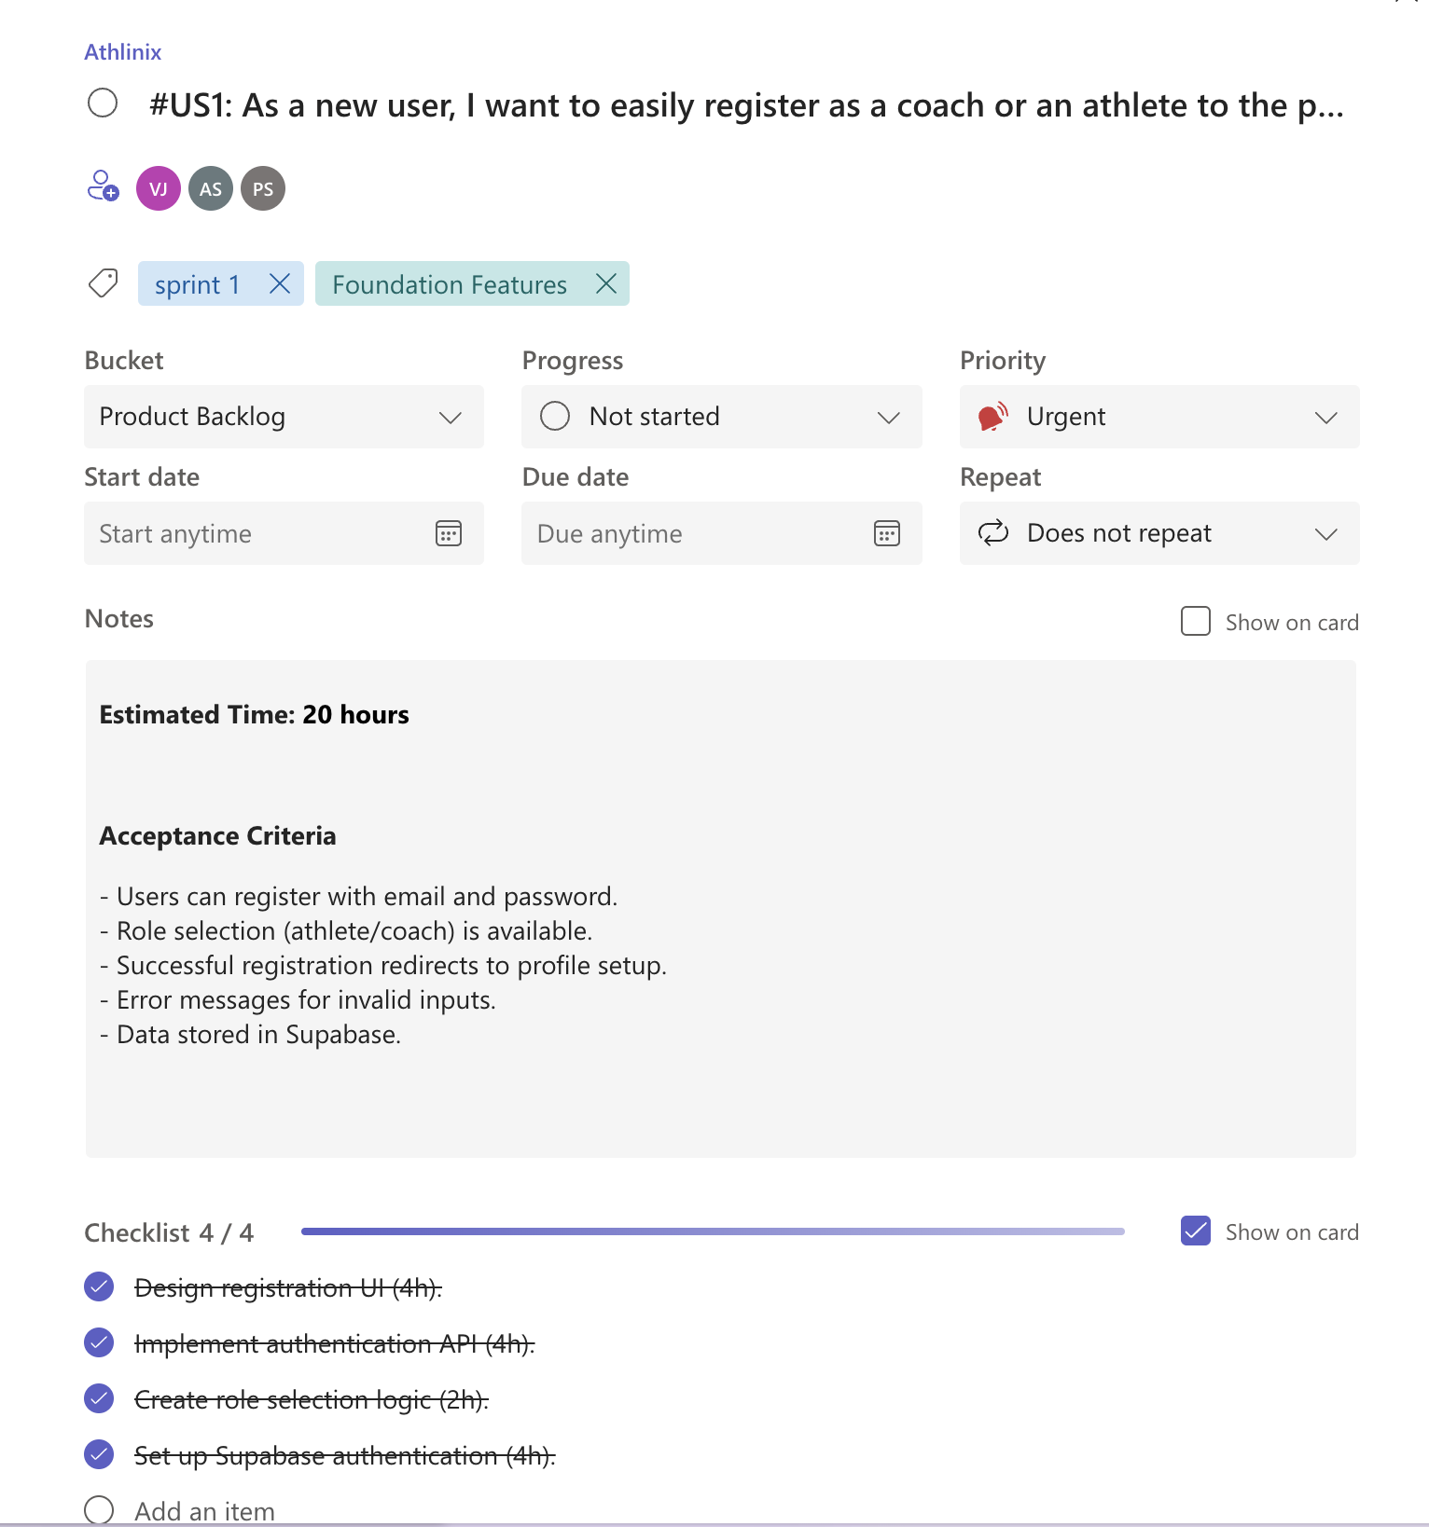
Figure 2.1 user story for user registration
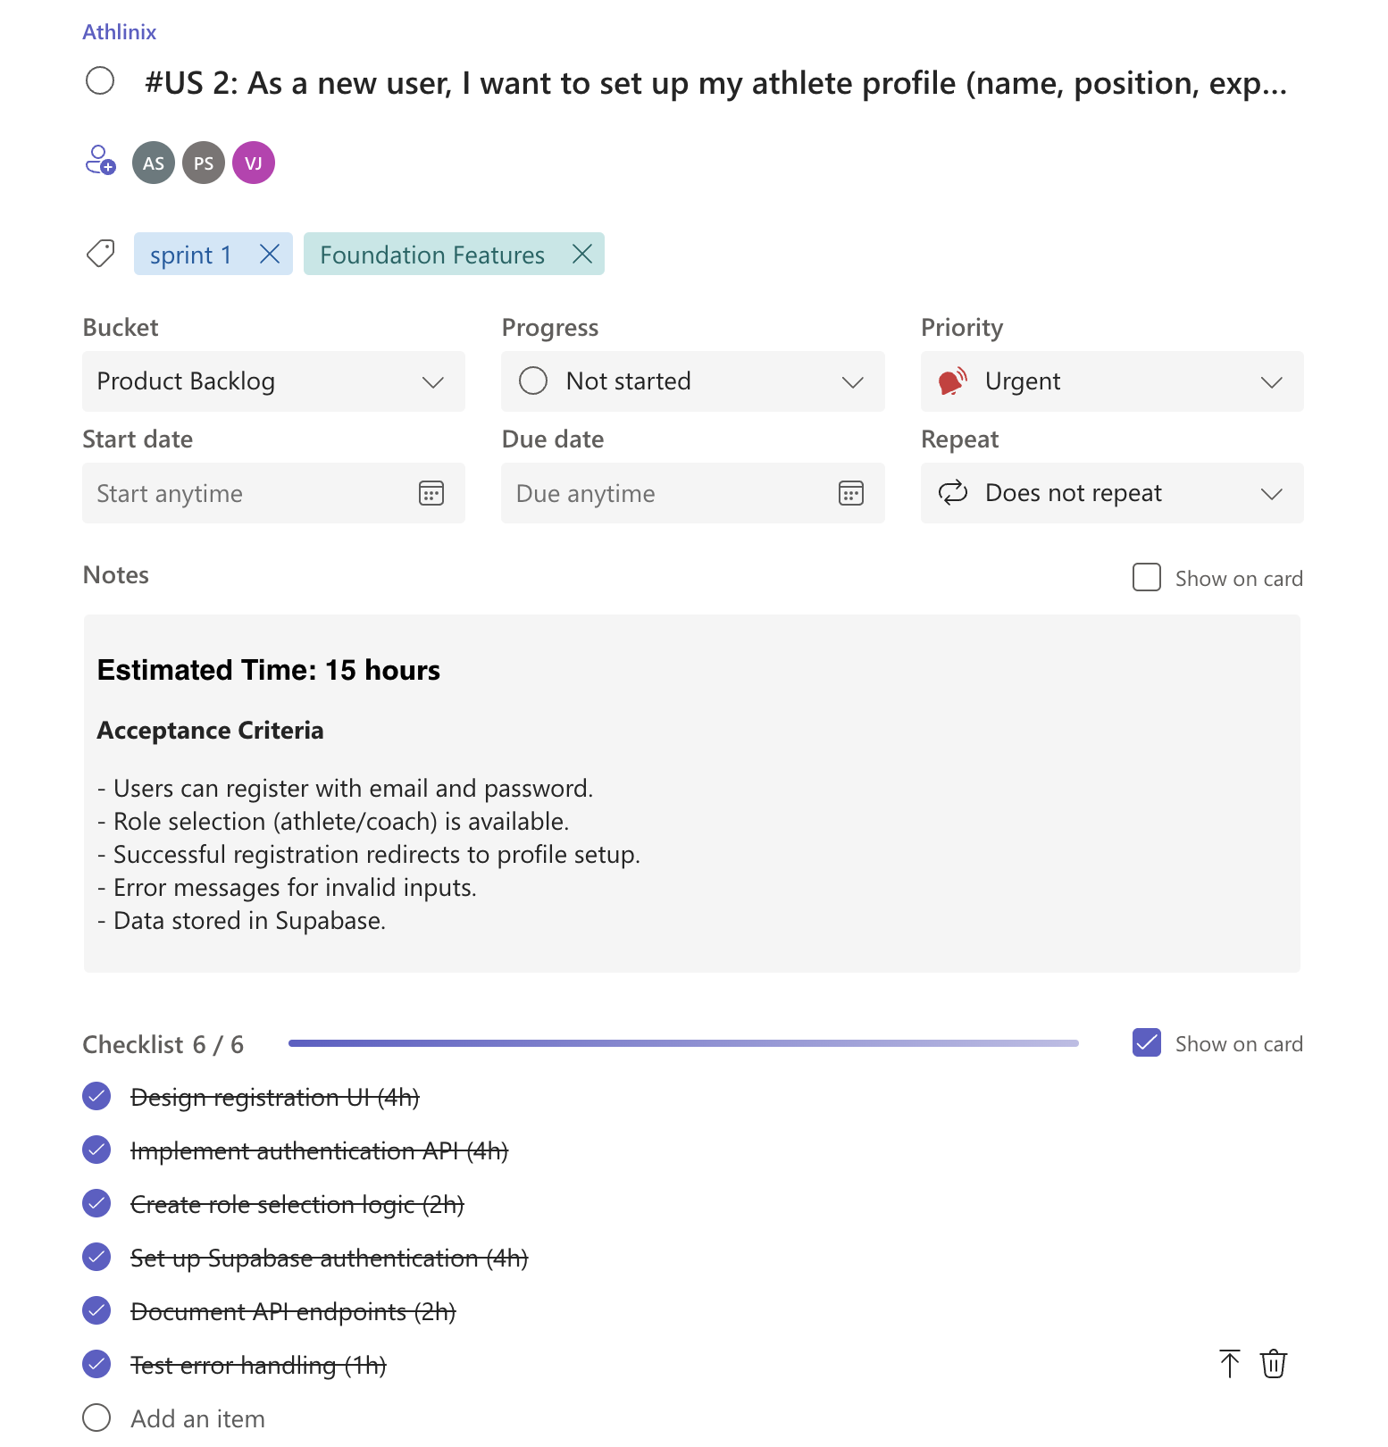
Figure 2.2 user story for profile creation
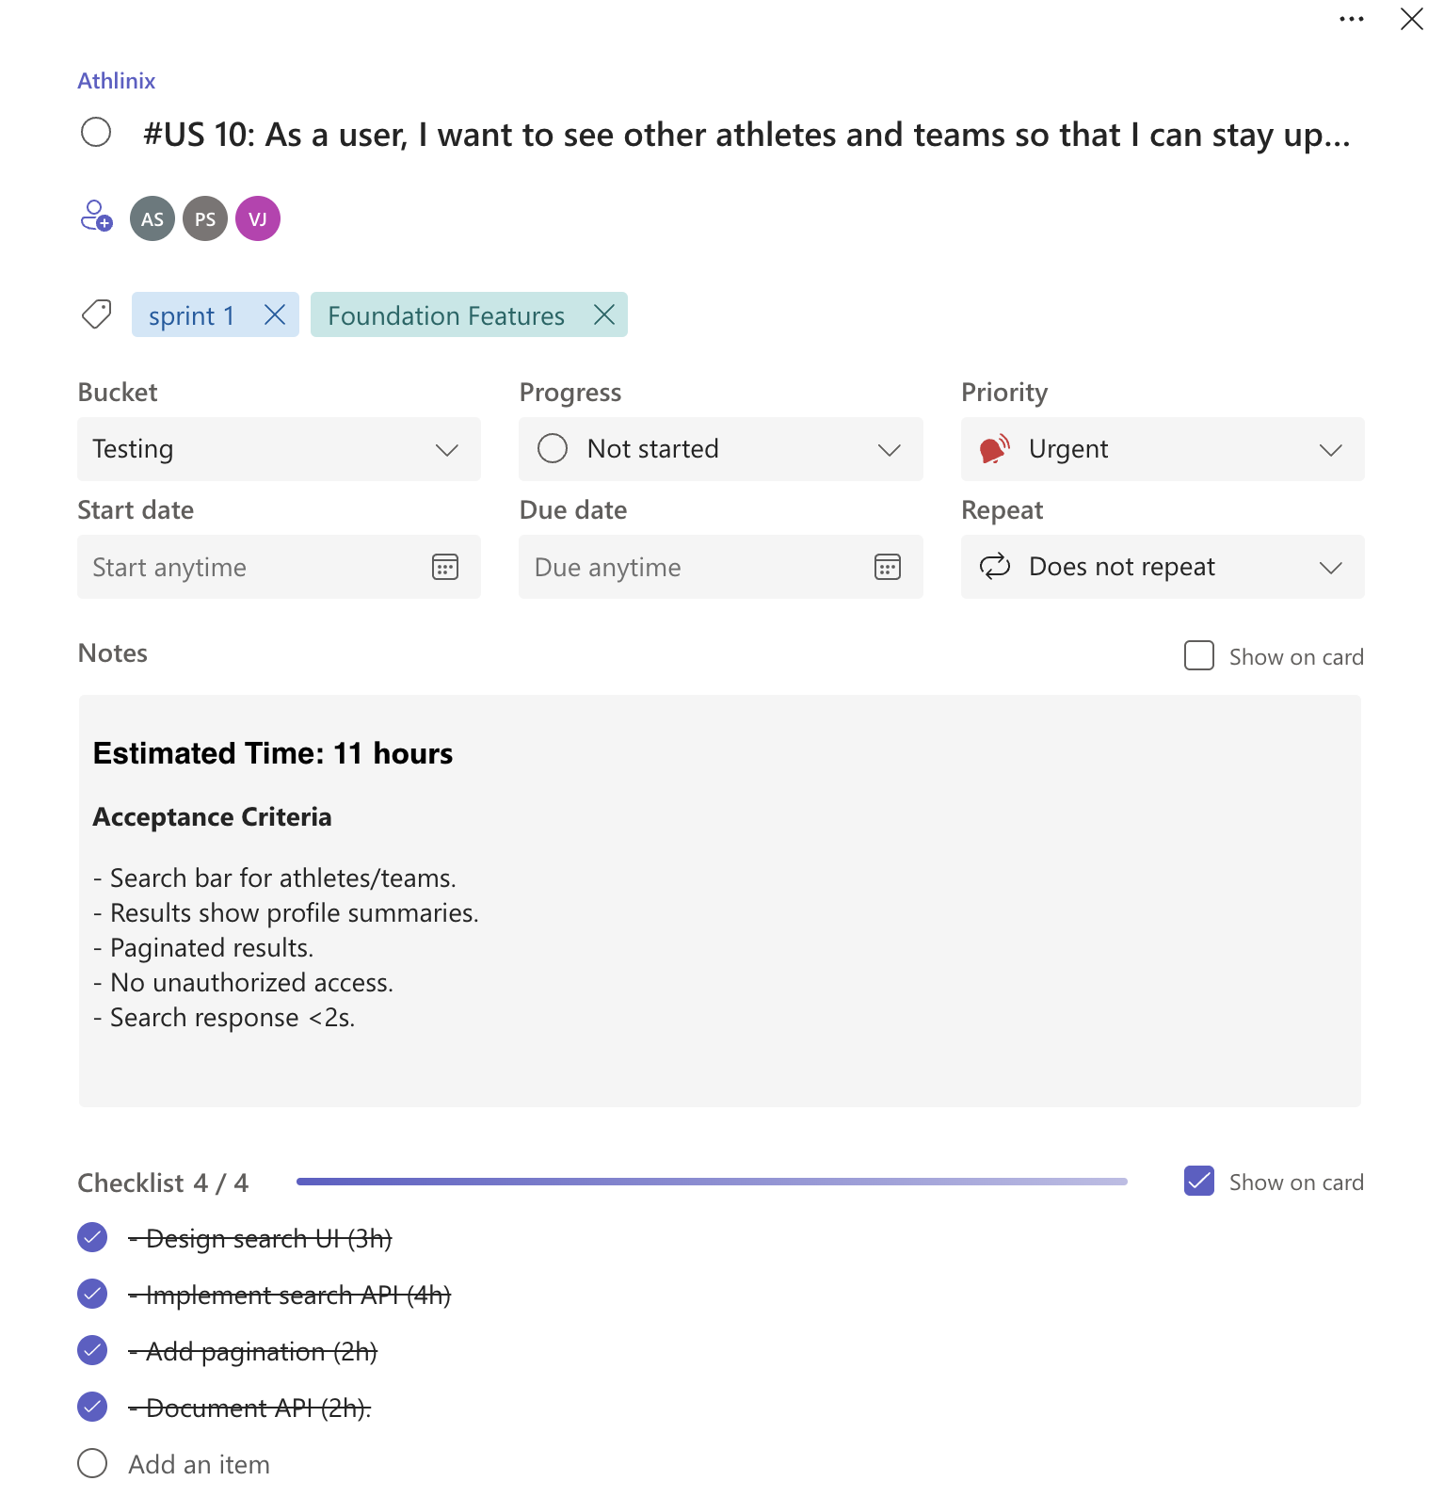
Figure 2.3 User story for search functionality

2.1.2 Functional Document
2.1.2.1. Introduction
Sprint 1 laid the groundwork for the Rebound app by implementing user registration, profile creation, and search functionalities. These features enable users to join the platform, establish their presence, and connect with the community, forming the foundation for subsequent features like game logging and performance analysis.
2.1.2.2. Product Goal
To deliver a user-friendly onboarding experience that allows athletes and coaches to register, create profiles, and explore the community, ensuring accessibility and engagement from the first interaction.
2.1.2.3. Demography (Users, Location)
Users:
- Primary Users: Amateur and aspiring athletes (school-level, college-level, independent players), coaches, and team managers
- Secondary Users: Scouts, recruiters, parents of young athletes, clubs, and academies
- User Characteristics: Various skill levels, focused primarily on basketball
Location:
- Global reach with focus on areas with active participation in amateur and semi-professional basketball leagues

2.1.2.4. Business Processes
The key business processes include:
User Registration and Authentication:
- Users can register as either athletes or coaches
- Authentication ensures secure access to personalized content
Profile Management:
- Athletes can create and manage their profiles with details like name, position, experience
- Coaches can create and manage team profiles
Game Logging:
- Athletes can log game performances with detailed statistics
- Coaches can approve and validate game logs for accuracy
Performance Analytics:
- System generates visual representations of performance data
- Timeline view provides chronological tracking of progress
Team Management:
- Coaches can create teams and manage rosters
- Athletes can join teams and access team-specific features
Social Sharing:
- Users can create posts to share achievements and updates
- Searchable profiles allow discovery within the community
2.1.2.5. Features
This project focuses on implementing the following key features:
Feature 1: User Registration
- Description:
  - The platform provides personalized learning paths that guide users through courses and sessions based on their interests, skills, and learning objectives.
- User Story:
  - As a user, I want the platform to recommend a learning path that aligns with my goals, so I can learn efficiently and effectively.
Feature 2: Profile Creation
- Description:
  - The platform allows users to join or host live learning sessions where they can collaborate and learn from peers in real-time.
- User Story:
  - As a user, I want to participate in live learning sessions to gain knowledge from others in real-time.
Feature 3: Enhanced Search Functionality
- Description:
  - The platform offers advanced search options, allowing users to find learning sessions and content based on specific criteria such as topic, difficulty level, and user ratings.
- User Story:
  - As a user, I want to easily find the most relevant content using filters and search tools, so I can quickly access what I need.

2.1.2.6. Authorization Matrix
Table 2.2 Access level Authorization Matrix
Role | Access Level
Athlete | Register, create/edit own profile, search for athletes/teams
Coach | Register, create/edit own profile, search for athletes/teams

2.1.2.7. Assumptions
- Users have valid email addresses for registration.
- Profile data is minimal to reduce onboarding friction.
- Search functionality handles small datasets initially, with scalability planned for future sprints.
2.1.3 Architecture Document
2.1.3.1. Application
- Frontend: Swift UIKit provides a native, responsive iOS interface for registration, profile creation, and search.
- Backend: Supabase manages user authentication, profile data storage, and search queries.
2.1.3.2 System Architecture- 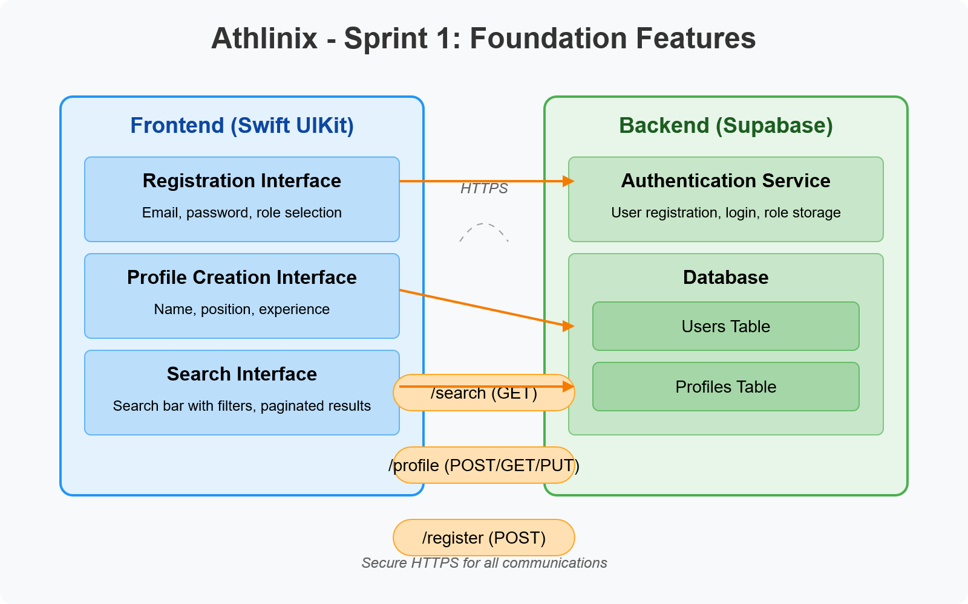
Figure 2.4: System Architecture for Sprint 1
A diagram illustrating:
- Frontend: Registration Form, Profile Creation Form, Search Bar.
- Backend: Supabase database with tables for users (email, role, profile data) and teams; APIs for registration, profile updates, and search.
- Authentication: Supabase Auth for secure user login and role-based access.
Data Exchange Contract:
- Frequency: Real-time for registration and profile updates; on-demand for search queries.
- Data Sets: User data (email, password hash, role), profile data (name, position, experience), search results (profile summaries).
- Modes: RESTful APIs for registration, profile management, and search; secure HTTPS for data transfer.

2.1.4 UI DESIGN
- Figure.2.5:.Registration.Interface
A mockup of the registration form with fields for email, password, and role selection (athlete/coach), featuring a clean, iOS-native design.
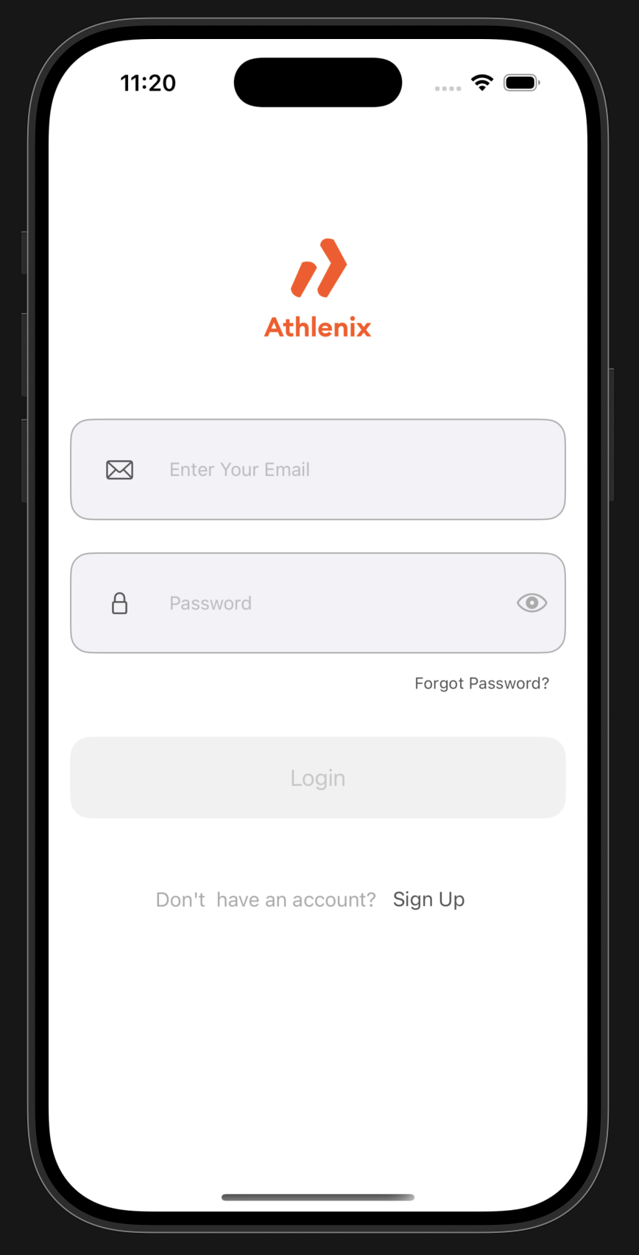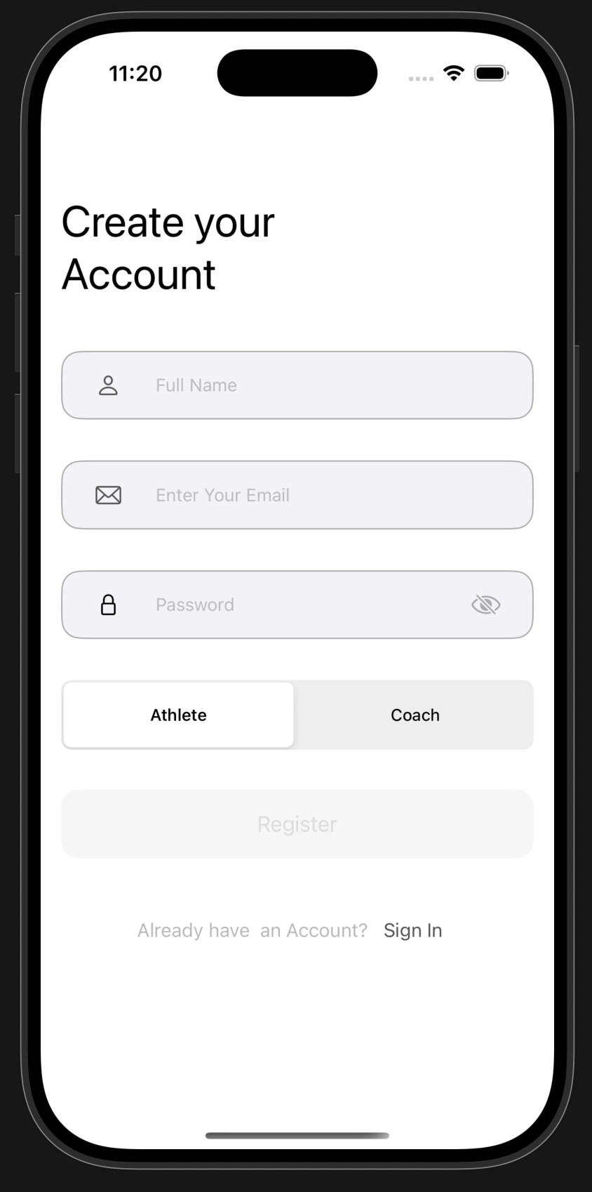
- Figure 2.6: Profile Interface
A mockup of the profile, including fields for name, position, experience.
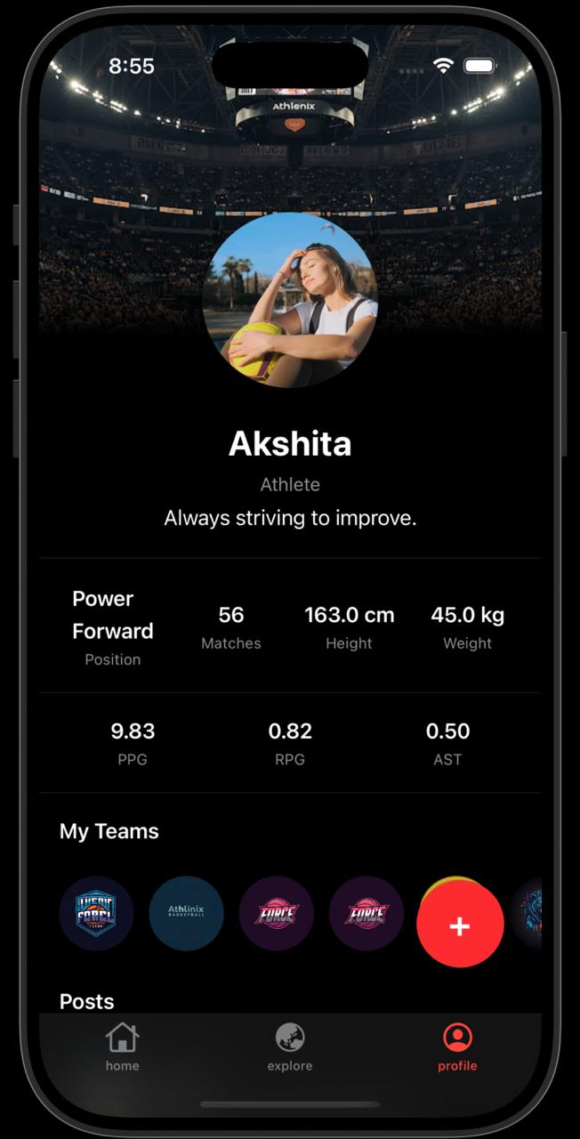
- Figure.2.7:.Search.Interface
A mockup of the search bar with filters (athletes/teams) and paginated results displaying profile summaries (name, position, team).
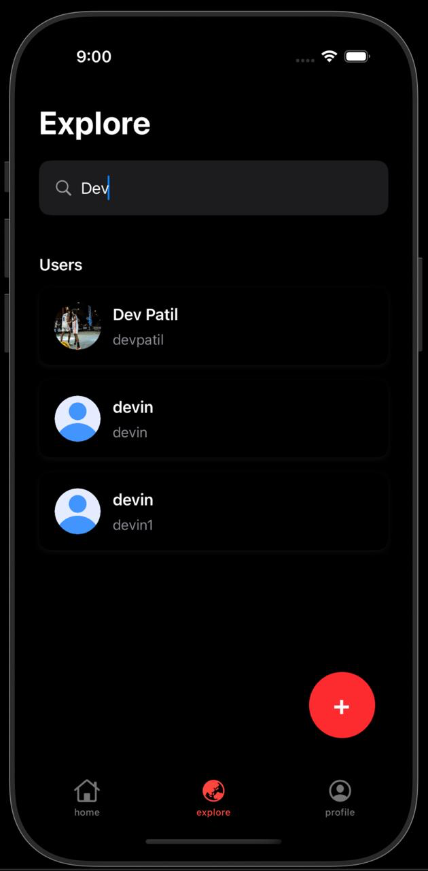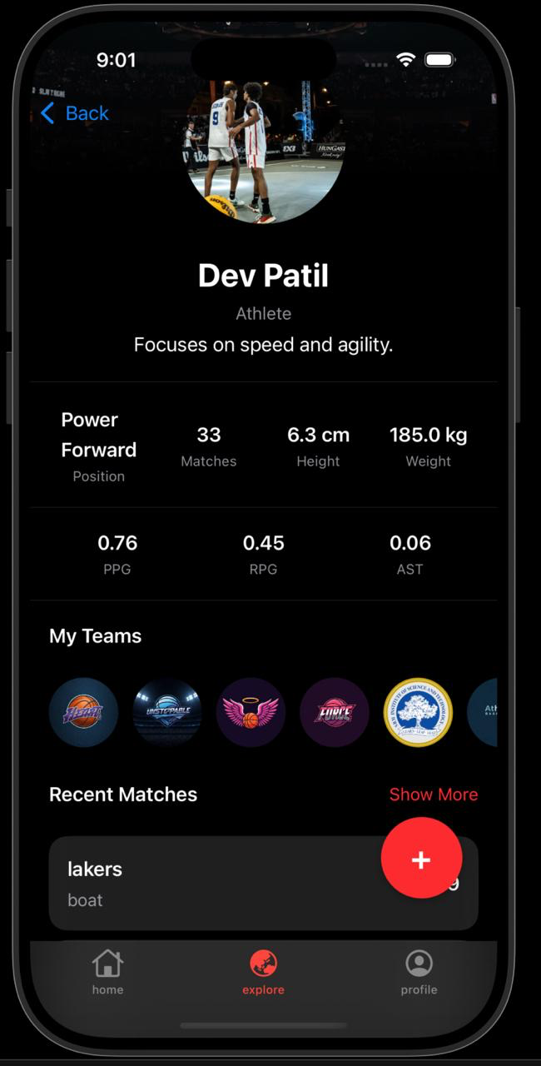
2.1.5 Functional Test Cases
Table 2.2: Functional Test Cases for Sprint 1
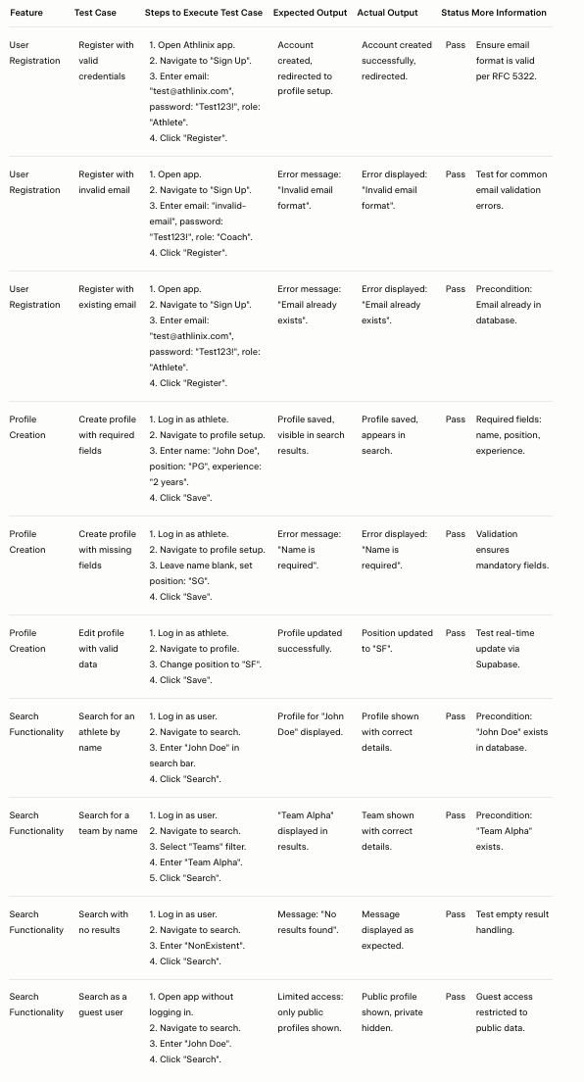
2.1.6 Daily Call Progress
Figure 2.8: Daily Call Progress for Sprint 1
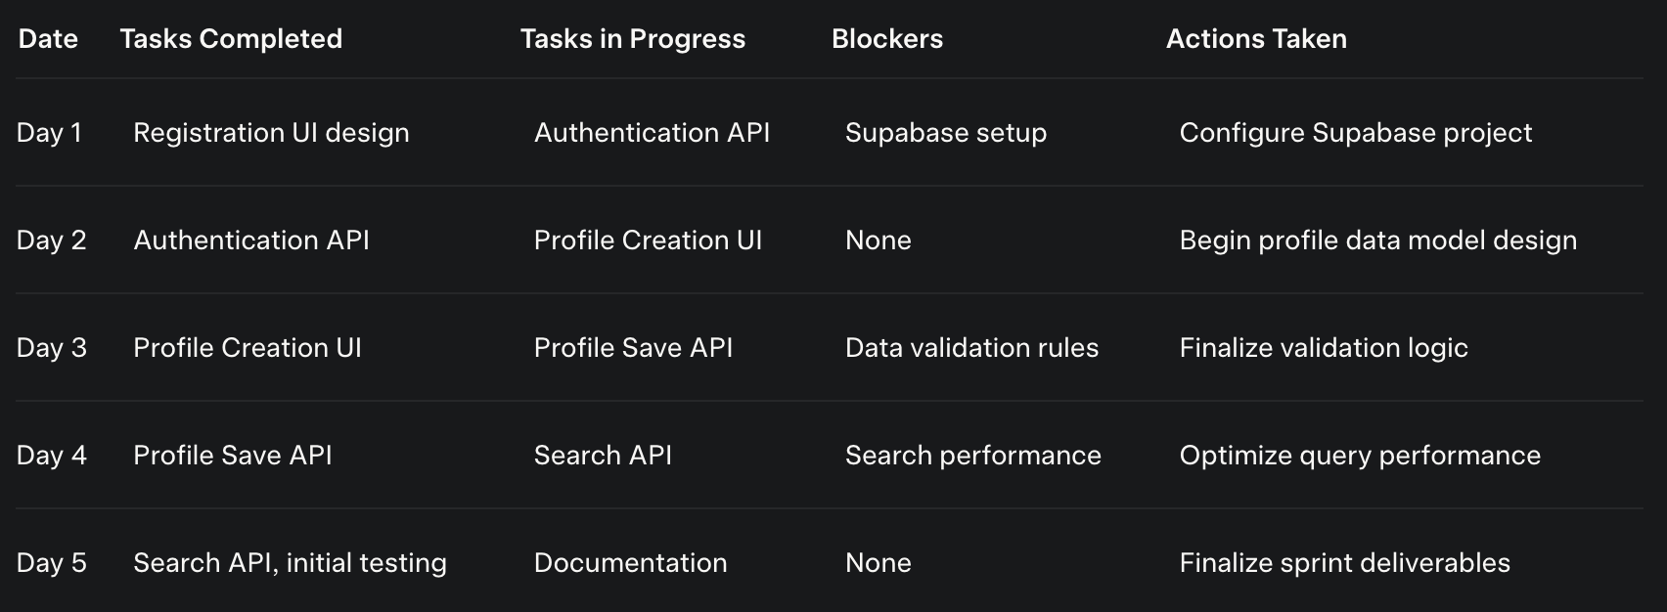
Figure 2.7 Standup meetings

2.1.7 Committed Vs Completed User Stories
Figure 2.9: Committed vs Completed User Stories for Sprint 1
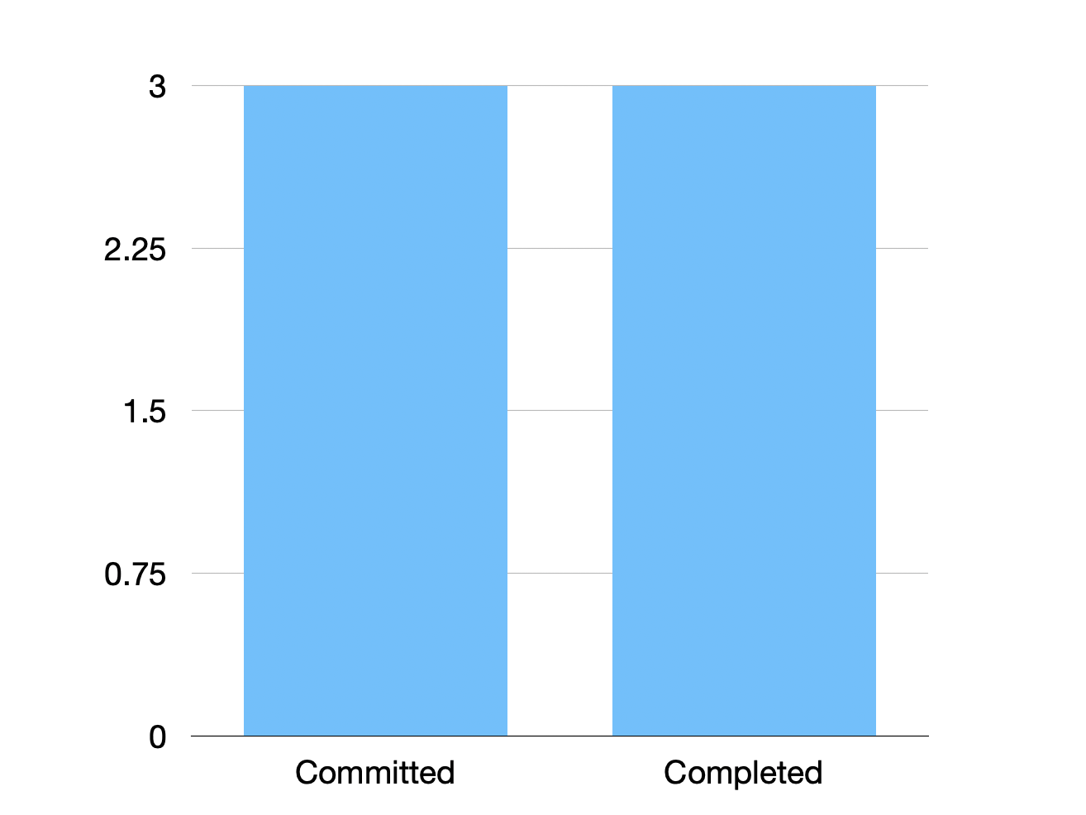
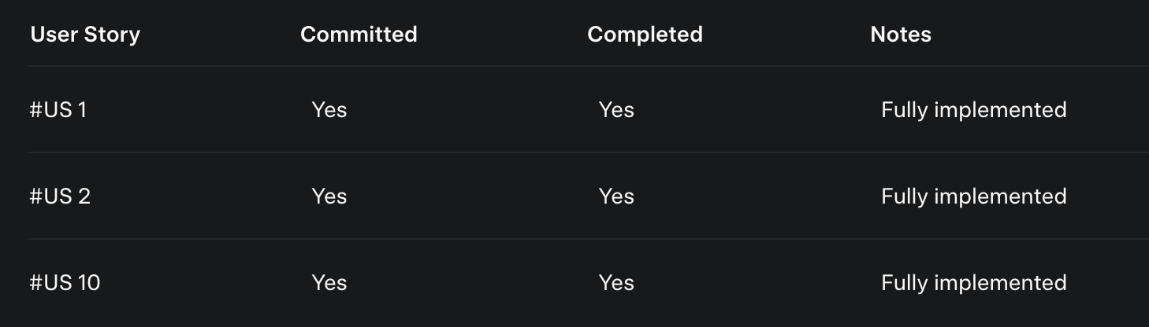

2.1.8 Sprint Retrospective
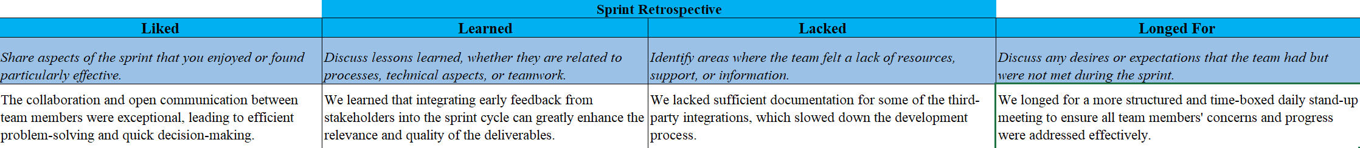
Figure 2.9 Sprint Retrospective for the Sprint 1

2.2 SPRINT 2
2.2.1 Sprint Goal with User Stories of Sprint 2

Sprint Goal
The primary objective of Sprint 2 was to implement the core functionality of game logging and basic performance tracking for athletes, while enabling coaches to verify and approve game logs. This sprint focused on delivering features that allow athletes to document their game statistics and coaches to ensure data accuracy, laying the foundation for the app’s central feature—game logging—while introducing basic performance visualization to provide initial insights into progress.
User.Stories:
The following user stories were addressed:
- #US 4: As an athlete, I want to log a new game so that I can track my performance and statistics.
- #US 5: As a coach, I want to approve game logs to ensure the accuracy of the data.
- #US 6: As an athlete, I want to view my game logs in a chronological timeline to see my progress over time.
- #US 7 (partial): As an athlete, I want to visualize my performance statistics through graphs and charts to understand my strengths and areas for improvement.

2.2.2 Functional Document
2.1.2.1. Introduction
Sprint 2 focused on developing the game logging feature, a cornerstone of the Rebound app. This feature enables athletes to input game statistics post-match and allows coaches to verify their accuracy, ensuring data integrity and reliability.
To provide a seamless and user-friendly mechanism for athletes to log game performances and for coaches to validate these logs, ensuring accurate and trustworthy data.
Demography (Users, Location):
- Users: Amateur and semi-professional basketball players (athletes) and their coaches.
- Location: The app is designed for iOS devices, with no geographical restrictions, leveraging cloud-based infrastructure.

Demography (Users, Location):
- Users: Amateur and semi-professional basketball players (athletes) and their coaches.
- Location: The app is designed for iOS devices, with no geographical restrictions, leveraging cloud-based infrastructure.
Business Processes:
- Athletes log game statistics, including date, opponent, result, and performance metrics (e.g., 2P, 3P, STL, PTS, AST, RPG).
- Coaches review and approve or reject logged statistics to ensure accuracy.
- Approved logs are stored and accessible in a chronological timeline for athletes.
Features:
- Game Logging Form: A user-friendly interface for athletes to input game details and statistics.
- Coach Approval Interface: A dashboard for coaches to review pending game logs and approve or reject them.
- Game Timeline View: Displays approved game logs in chronological order, with filters for date ranges or opponents.
- Basic Performance Visualization: Simple charts for key metrics like PPG, RPG, and AST.
Table 2.4 Authorization Matrix for Sprint 2
Role | Access Level
Athlete | Log games, view own timeline, request approvals
Coach | Approve/reject game logs, view team members

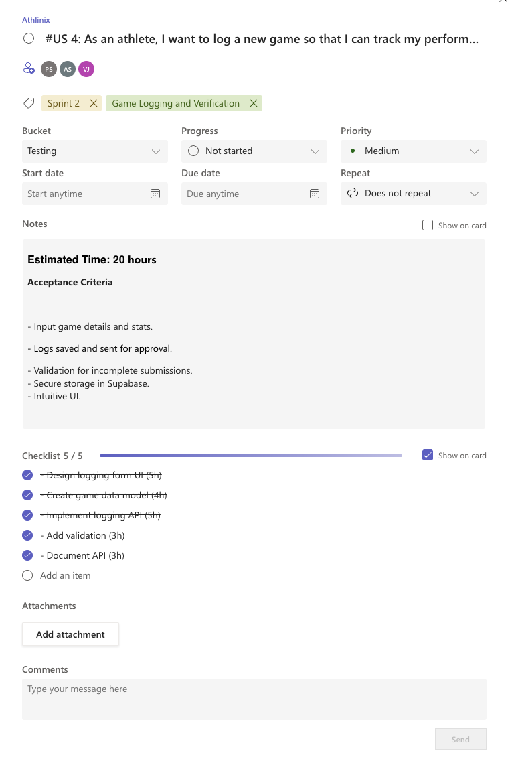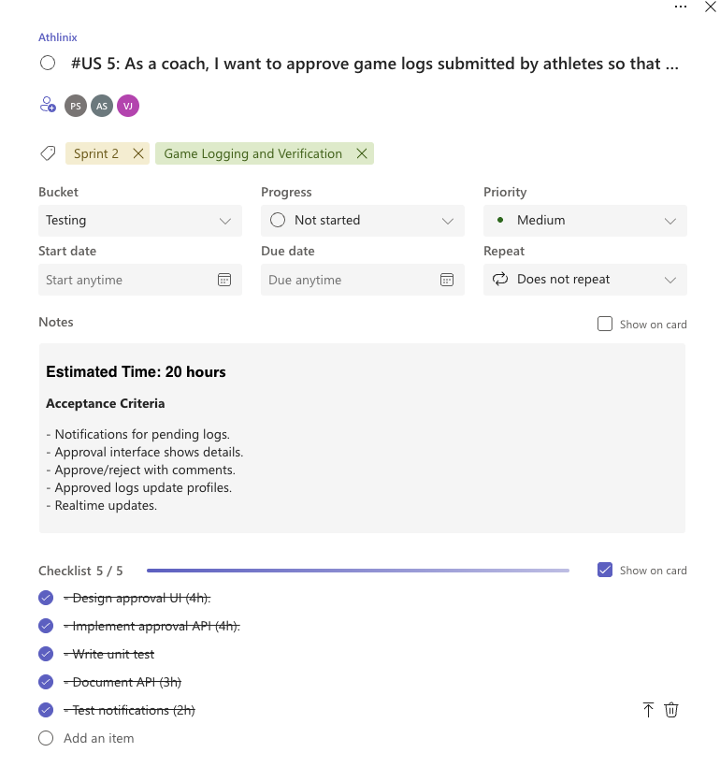
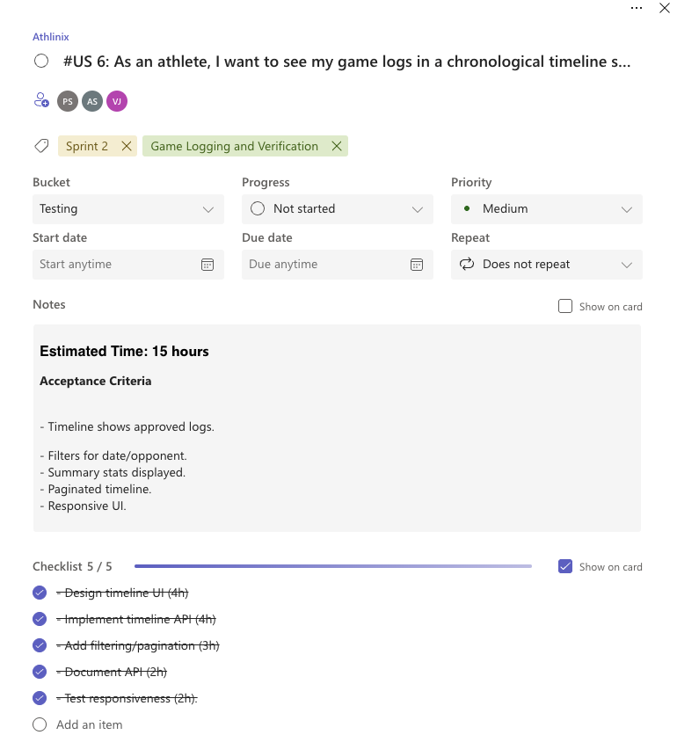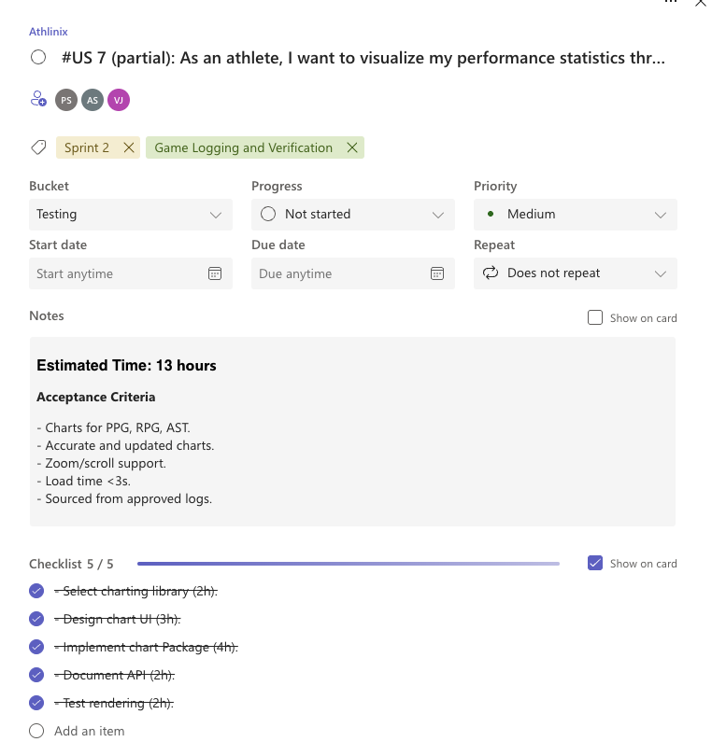

Assumptions:
- Athletes have access to game statistics shortly after matches.
- Coaches review and approve logs within 24-48 hours.
- The system handles multiple concurrent log submissions efficiently.
2.2.3 Architecture Document
Application:
- Frontend: Swift UIKit ensures a native, responsive iOS interface.
- Backend: Supabase manages database operations, authentication, and real-time updates.
System Architecture:
Figure 2.13: System Architecture for Sprint 2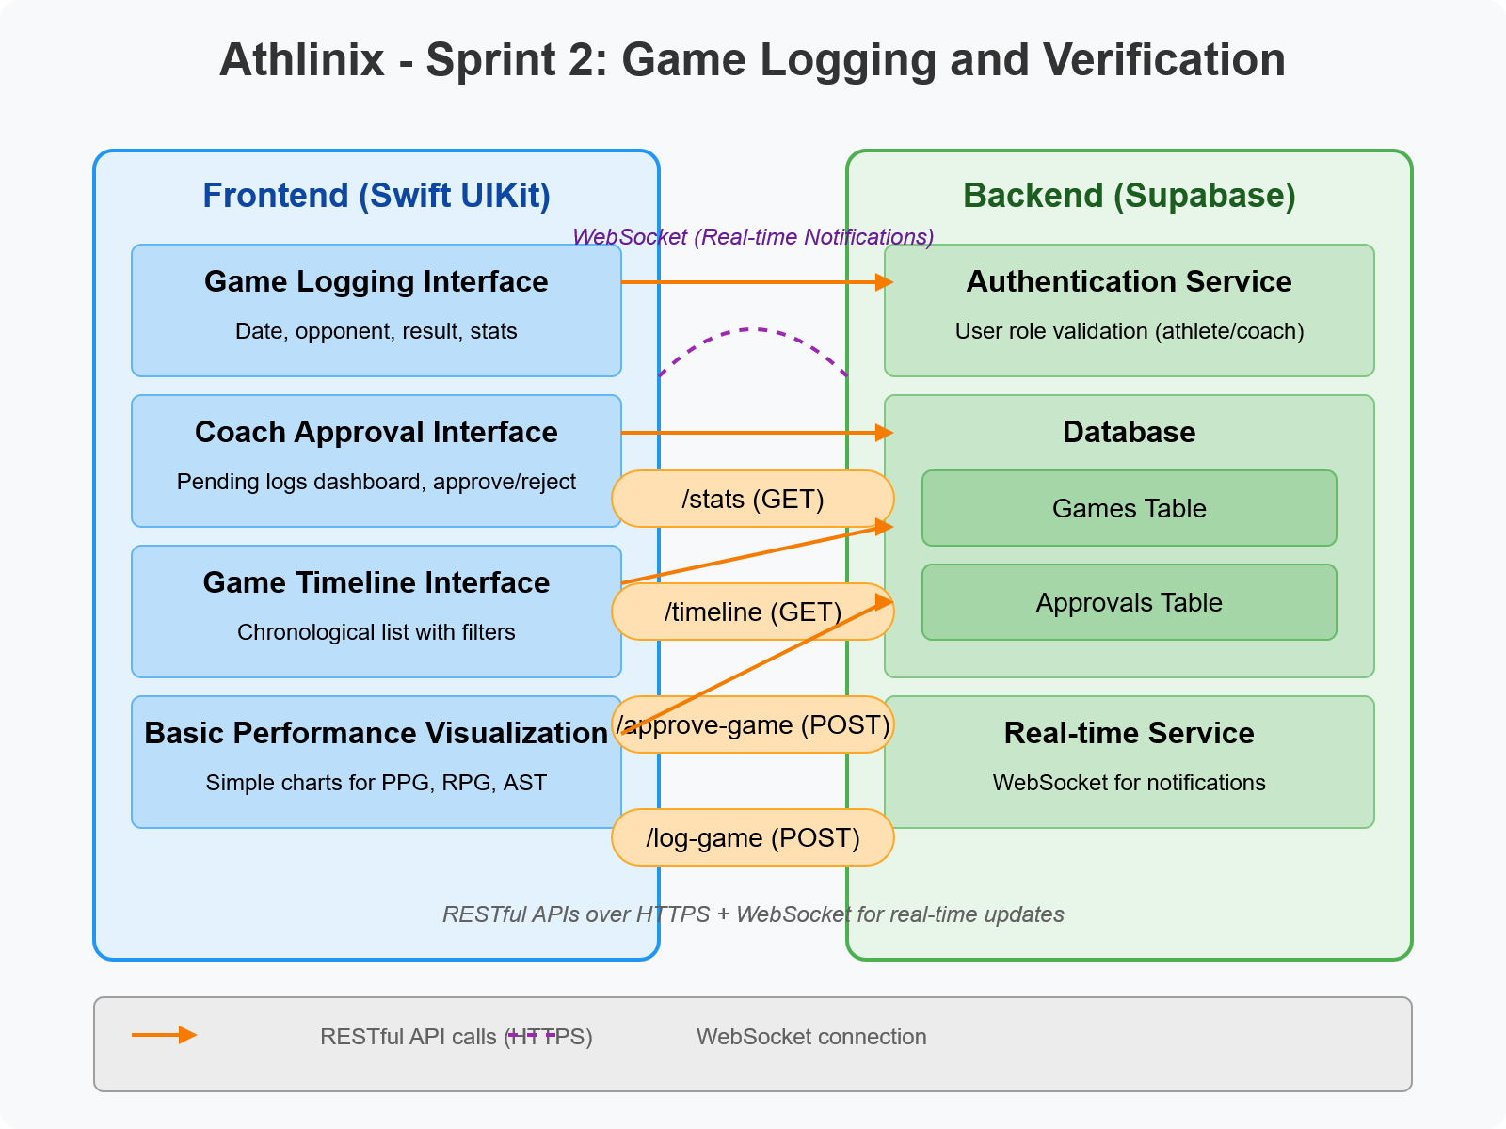
A diagram illustrating frontend-backend interactions, including:
- Frontend: Game Logging Form, Coach Approval Interface, Game Timeline View.
- Backend: Database tables for games, players, and teams; APIs for logging, approvals, and history retrieval.
- Real-time Updates: WebSocket for notifying coaches of new logs and updating athletes on approval status.
Data Exchange Contract:
- Frequency: Real-time for approvals; periodic for data syncing.
- Data Sets: Game logs (date, opponent, result, statistics), approval statuses, user profiles.
- Modes: RESTful APIs for logging and retrieval; WebSocket for real-time notifications.

2.2.4 UI Design

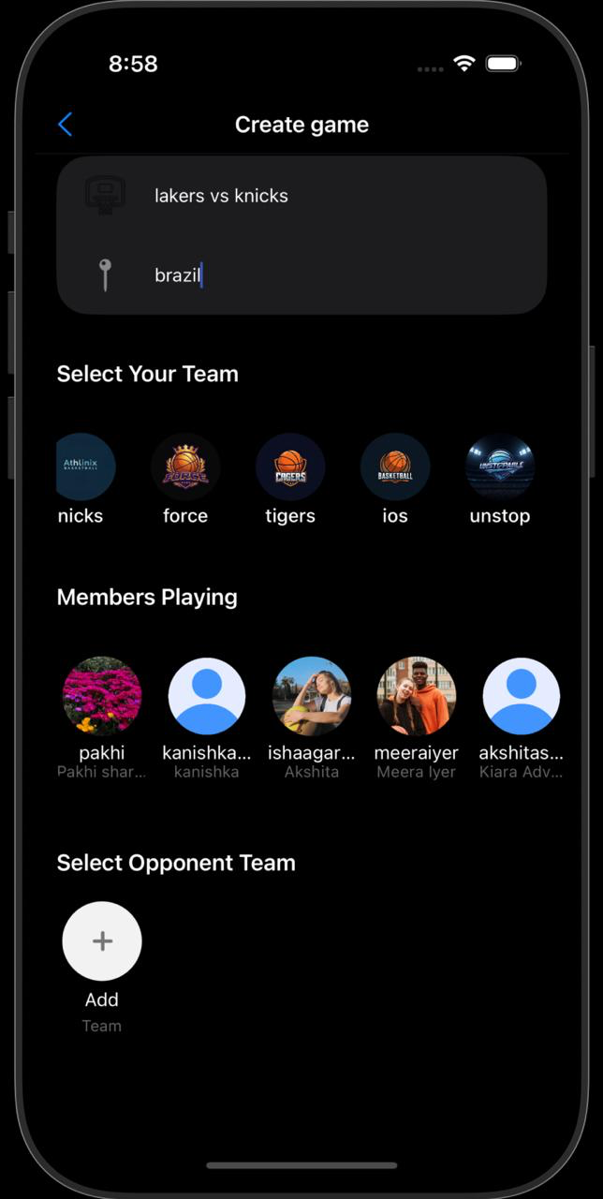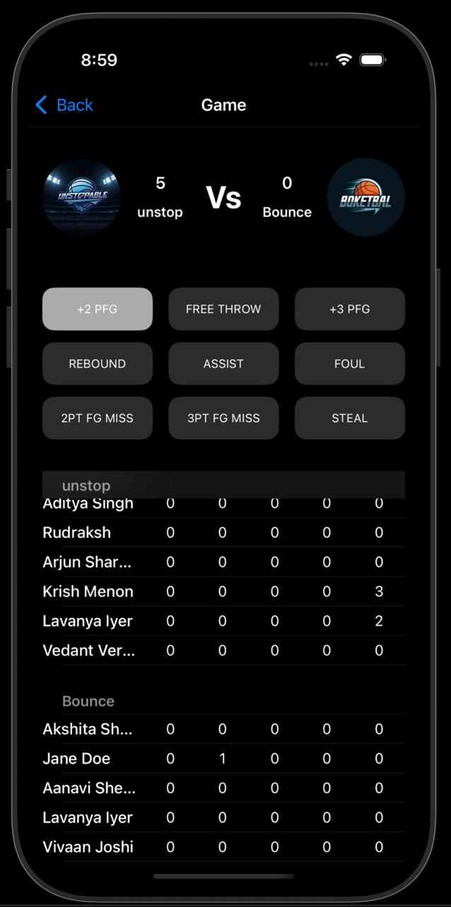
- Figure 2.14: Game Logging Form
A mockup of the form for inputting game details and statistics, with fields for date, opponent, result, and metrics like 2P, 3P, STL, PTS.
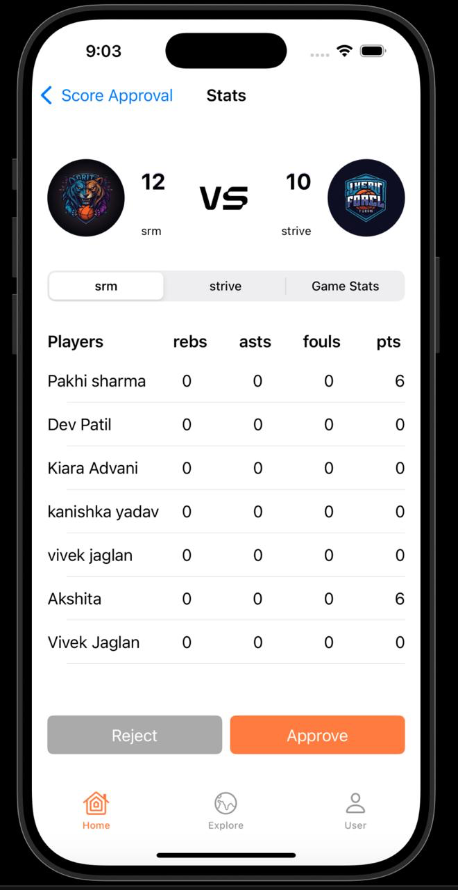
- Figure 2.15: Coach Approval Interface
A dashboard mockup for coaches to view pending logs, review statistics, and approve/reject.

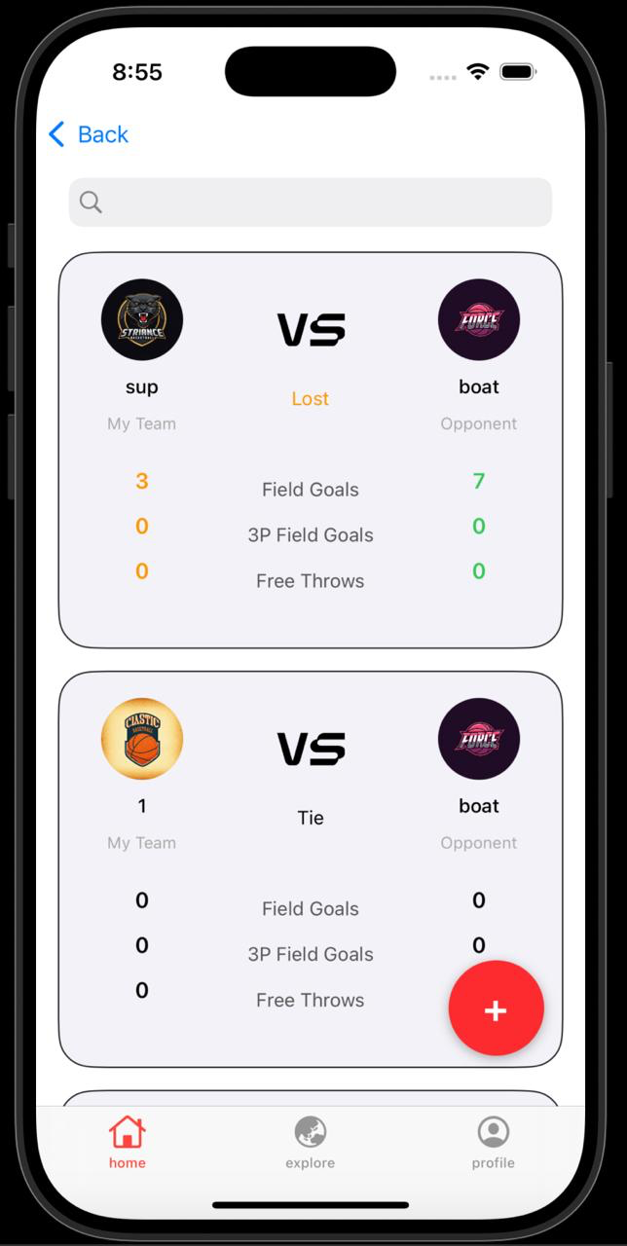
- Figure 2.16: Game Timeline View
A mockup of the timeline feature, showing approved game logs with summarized statistics.
2.2.5 Functional Test Cases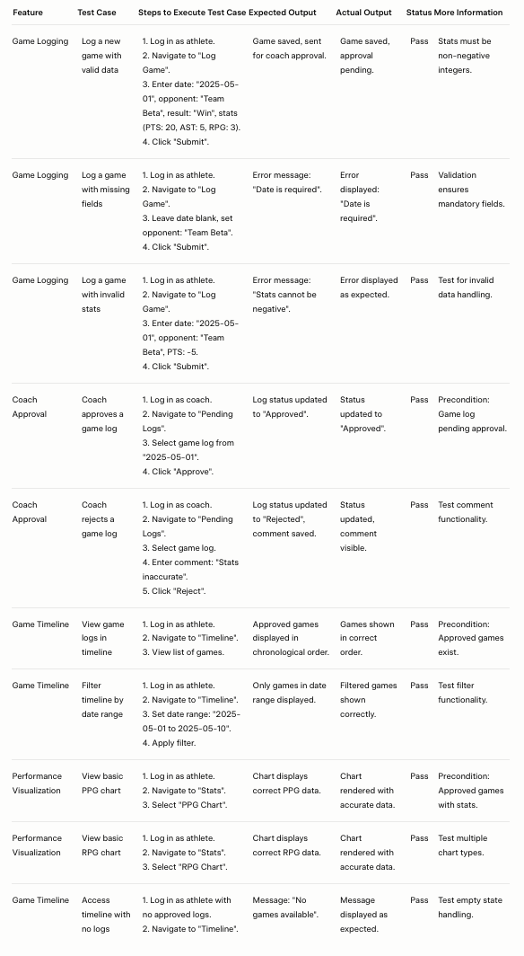

2.2.6 Daily Call Progress
A table daily standup outcomes:
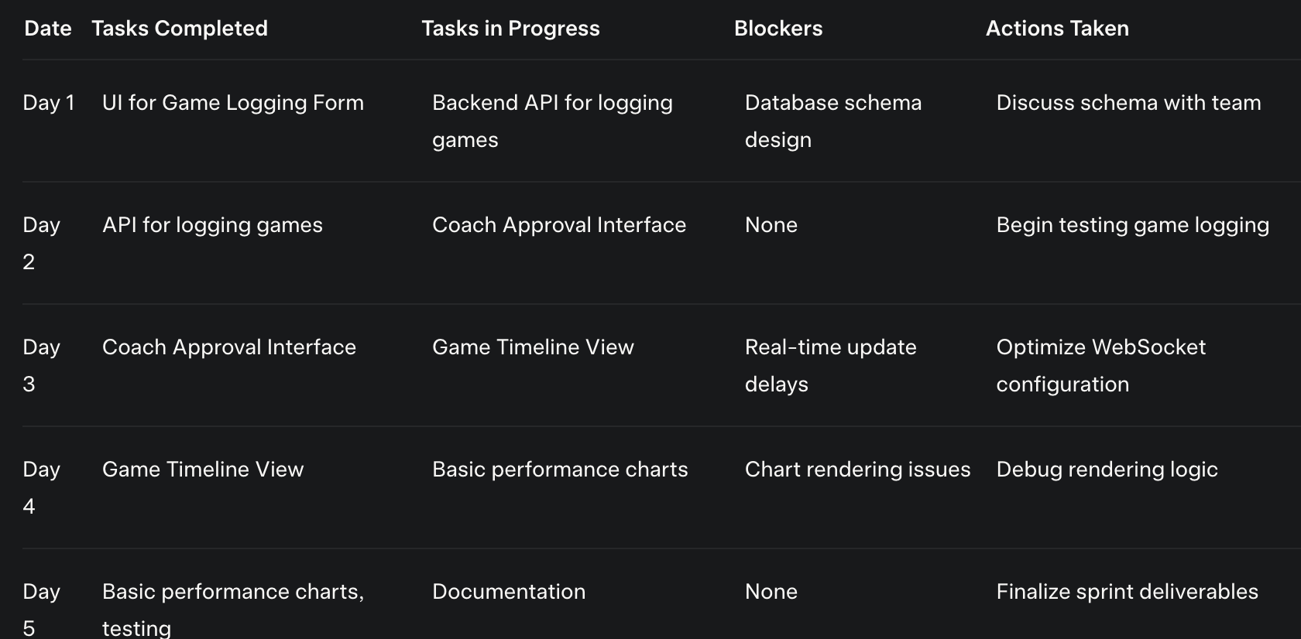
Figure 2.17: Daily Call Progress for Sprint 2

2.2.7 COMMITTED Vs COMPLETED USER STORIES
Figure 2.18: Committed vs Completed User Stories for Sprint 2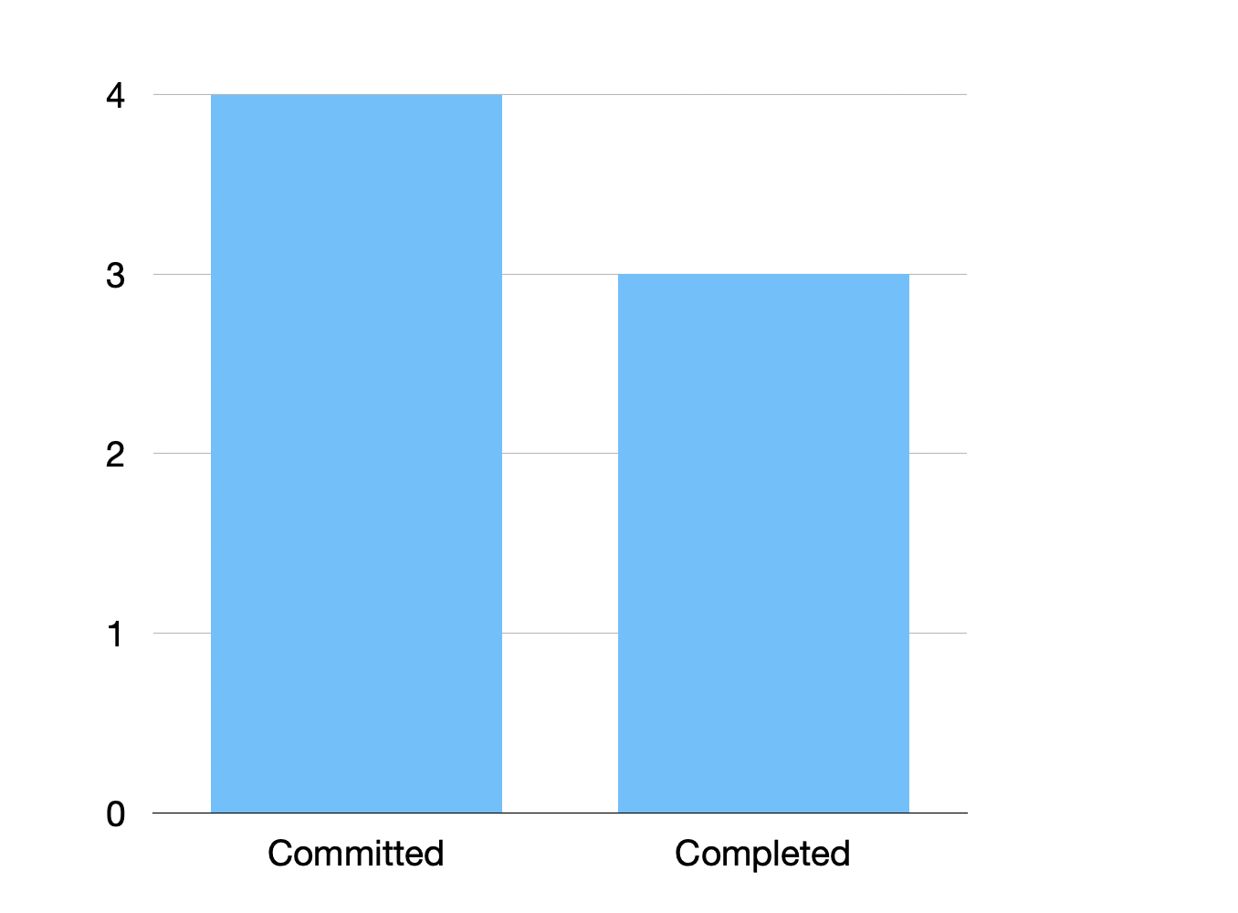
A table comparing planned and completed user stories:
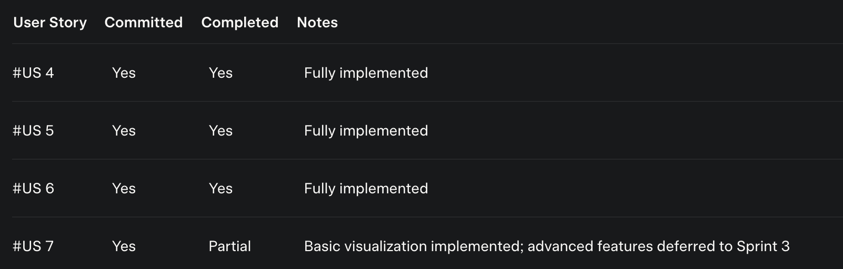

2.2.8 Sprint Retrospective
Content:
The Sprint 2 retrospective highlighted:
- What Went Well:
  - Successful implementation of game logging, a critical feature.
  - Improved collaboration between frontend and backend teams.
- What Could Be Improved:
  - Daily standups could be more structured to address blockers faster.
  - Coach Approval Interface UI needs better usability for non-technical users.
- Action Items:
  - Implement detailed testing plans to catch edge cases.
  - Enhance UI/UX feedback loops with stakeholder reviews.
  - Optimize real-time notifications for performance.
Figure 2.19: Sprint Retrospective Summary
2.3 Sprint 3
2.3.1 Sprint Goal with User Stories of Sprint 3

Sprint.Goal:
The primary objective of Sprint 3 was to complete the core functionality of the Rebound app by implementing team management features, enabling athletes to share their achievements through posts, and enhancing performance analysis with advanced visualization tools and personalized dashboards. This sprint aimed to finalize the MVP by delivering a comprehensive platform for team collaboration, social engagement, and data-driven insights, ensuring athletes and coaches can fully leverage the app for performance tracking and recognition.

User.Stories:
The following user stories were addressed:
- #US 3: As a new user, I want to add my team to my profile so that I can manage team-related data.
- #US 8: As a coach, I want to create a team so that I can manage all players and their performance data.
- #US 9: As an athlete, I want to create a post so that I can share my achievements, thoughts, and stats with my followers.
- #US 7 (advanced): As an athlete, I want to visualize my performance statistics through graphs and charts to analyze my growth in detail.
- #US 11: As an athlete, I want to have a personalized dashboard displaying my key statistics (e.g., points per game, rebounds per game, shooting percentage) to easily track my improvement.
Figure 2.20: User Stories for Sprint 3
A table listing the user stories with their descriptions, priorities, and completion statuses (e.g., "Completed").
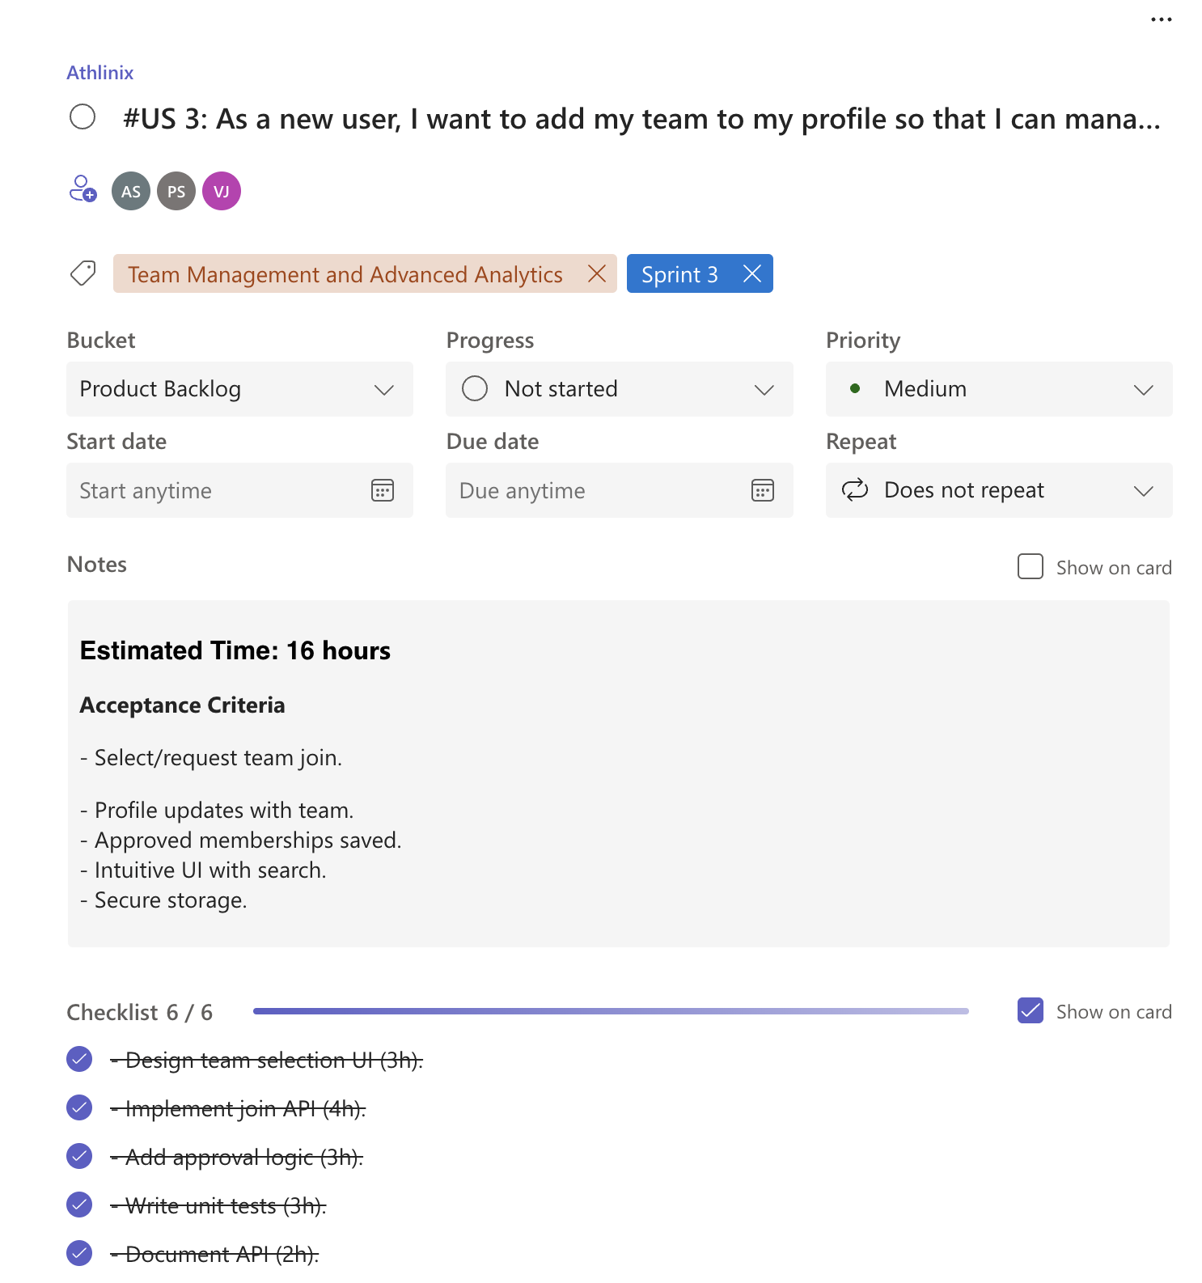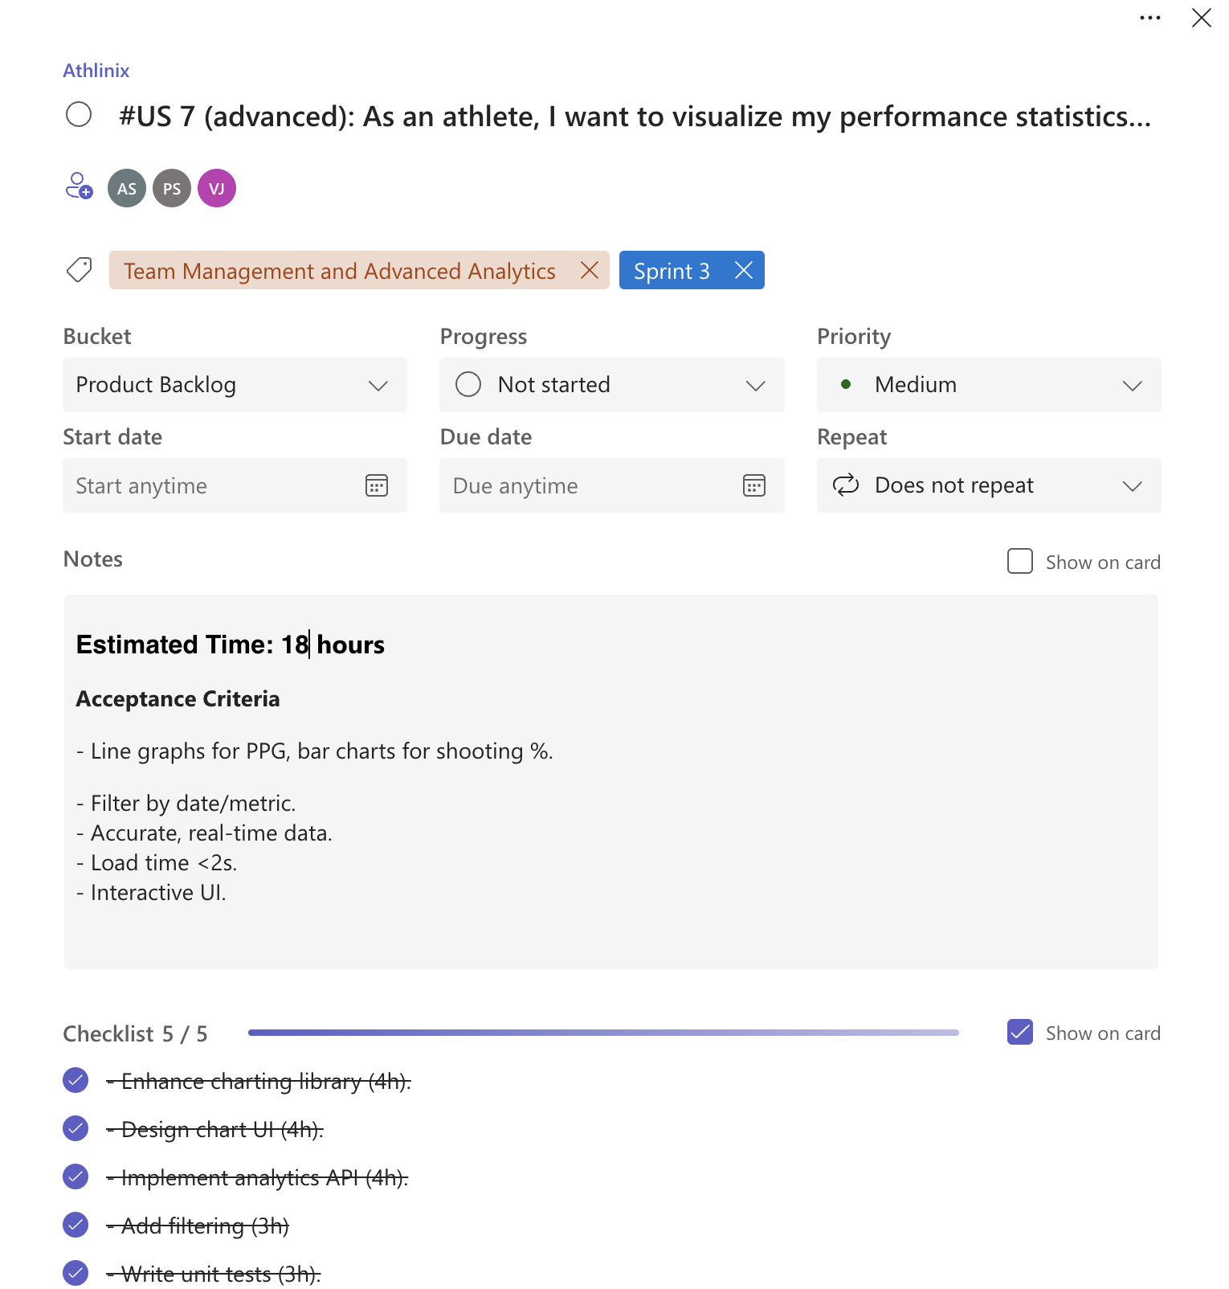

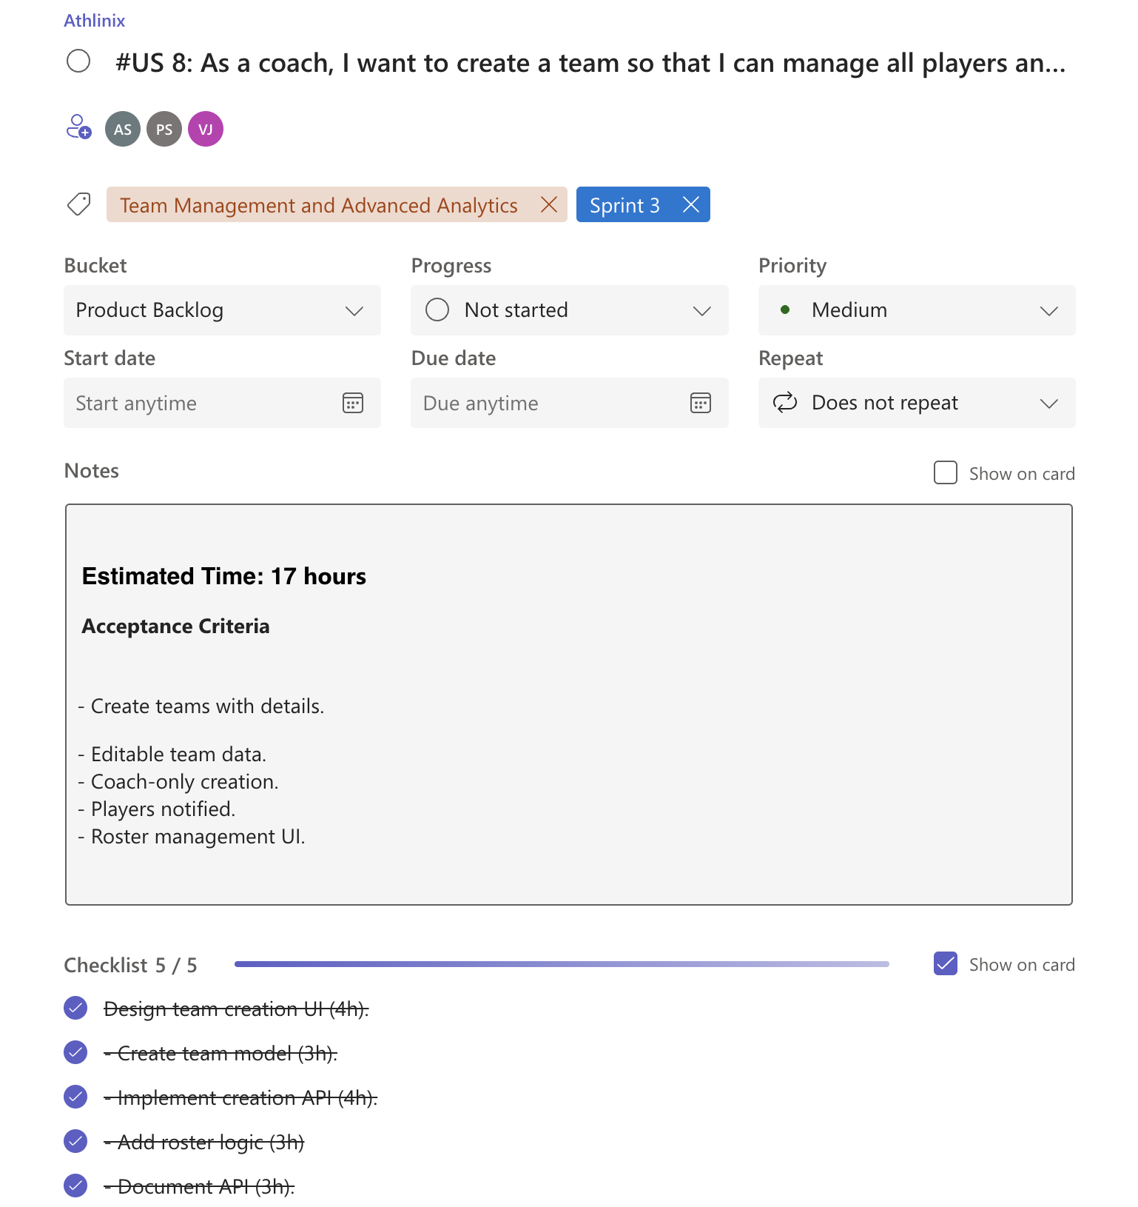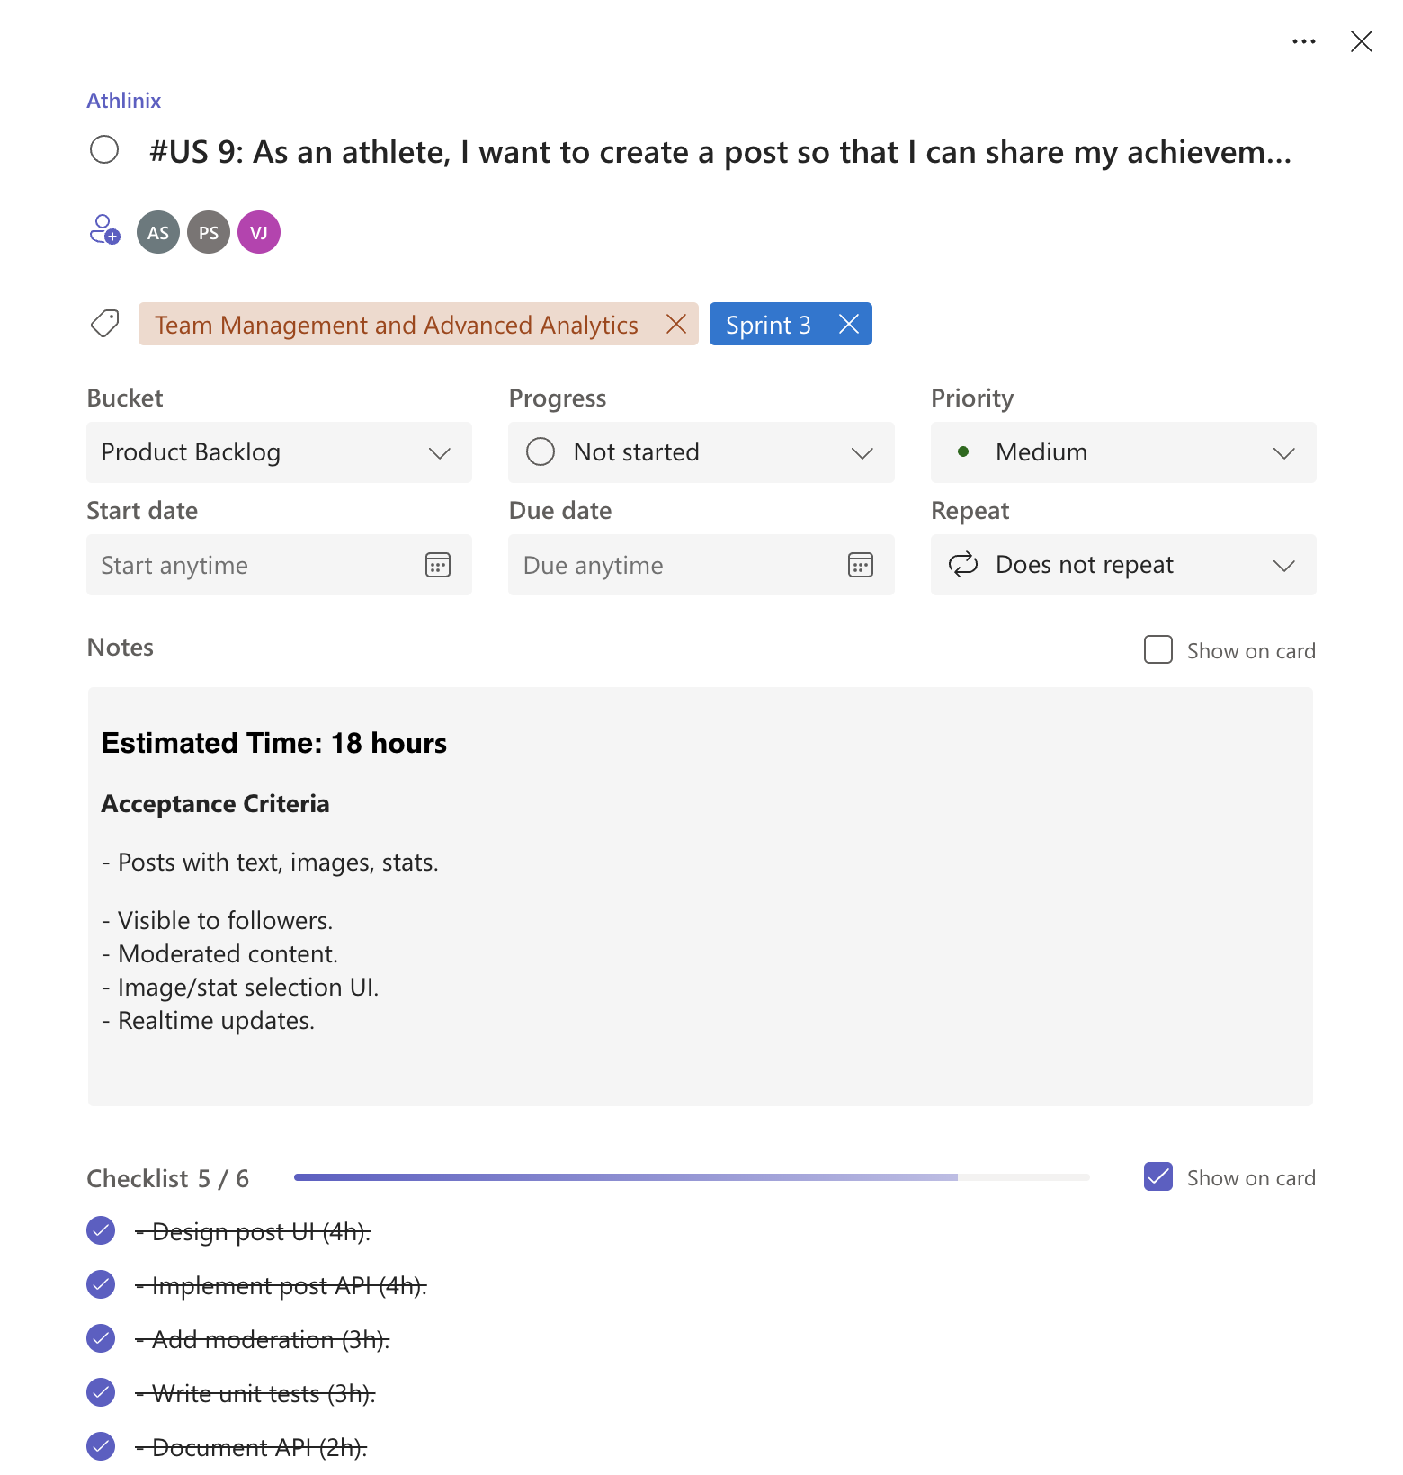

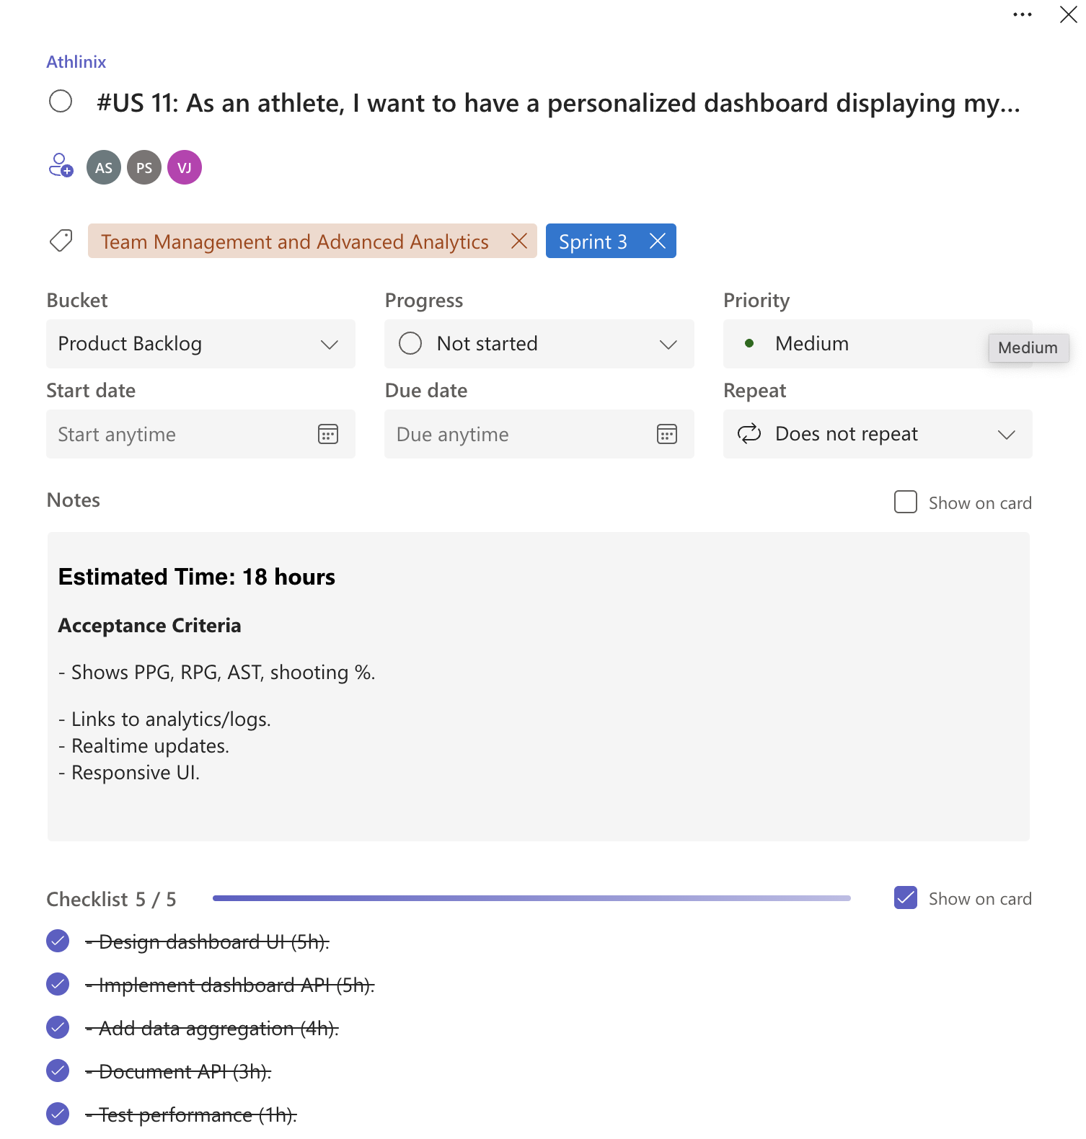
Figure 2.21: Planner Board for Sprint 3
A visual representation of the user stories on an Agile planning board, showing progression through stages like "To Do," "In Progress," and "Done."

2.3.2 Functional Document
Introduction:
Sprint 3 focused on completing the Rebound MVP by implementing team management, social sharing, and advanced analytics features. These additions enable coaches to organize teams, athletes to share their progress, and both to gain deeper insights through enhanced performance visualizations and personalized dashboards.
Product.Goal:
To deliver a fully functional platform that supports team collaboration, social engagement, and advanced performance tracking, aligning with Rebound’s vision of empowering amateur and semi-professional athletes and coaches.
Demography (Users, Location):
- Users: Amateur and semi-professional basketball players (athletes), coaches, and team managers.
- Location: Global, accessible via iOS devices, with cloud-based infrastructure ensuring scalability.
Business Processes:
- Team Creation and Management: Coaches create teams, assign players, and manage rosters. Athletes link their profiles to teams.
- Post Creation: Athletes create and share posts with text, images, and game statistics to engage with followers.
- Advanced Performance Visualization: Athletes view detailed graphs and charts for metrics like PPG, RPG, AST, and shooting percentages.
- Personalized Dashboard: Aggregates key statistics and provides quick access to performance trends and team data.
Features:
- Team Creation Interface: Allows coaches to set up teams with names, descriptions, and player rosters.
- Team Profile Linking: Enables athletes to associate their profiles with teams.
- Post Creation and Viewing: Supports sharing game achievements and viewing others’ posts.
- Advanced Performance Visualization: Includes detailed charts (e.g., line graphs for PPG over time, bar charts for shooting percentages).
- Personalized Dashboard: Displays key metrics (PPG, RPG, AST, shooting percentage) with links to detailed analytics.
Authorization.Matrix:
Table 2.6: Authorization Matrix for Sprint 3
Role | Access Level
Athlete | Link profile to team, create/view posts, access dashboard and analytics
Coach | Create/manage teams, view team analytics,

Assumptions:
- Users have stable internet access for real-time post sharing and analytics.
- Team creation is limited to coaches to ensure data integrity.
- Performance data is aggregated efficiently for dashboard rendering.

2.3.3 Architecture Document
Application:
- Frontend: Swift UIKit delivers a native, responsive iOS interface for team management, post creation, and analytics.
- Backend: Supabase manages database operations, real-time updates, and API interactions.
System Architecture:
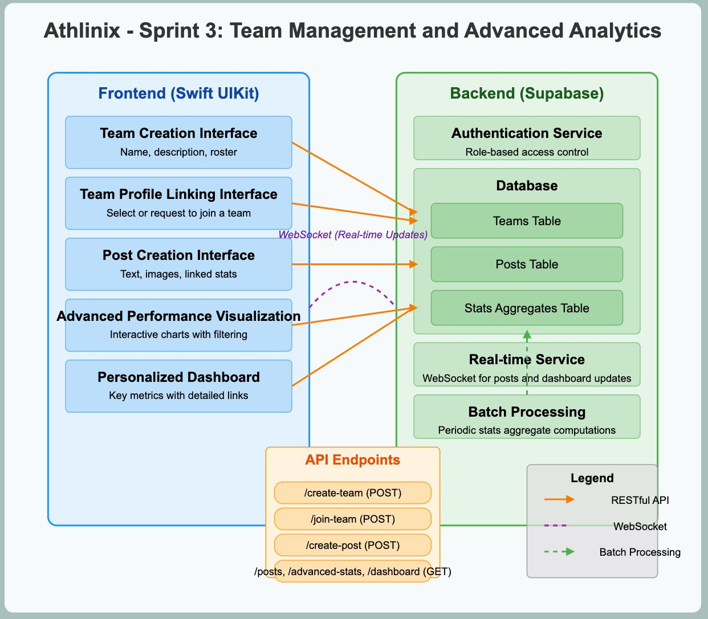
Figure 2.23: System Architecture for Sprint 3
A diagram illustrating:
- Frontend: Team Creation Interface, Post Creation/Viewing, Advanced Analytics Dashboard.
- Backend: Database tables for teams, posts, and aggregated statistics; APIs for team management, post handling, and analytics.
- Real-time Updates: WebSocket for post notifications and dashboard updates.
Data Exchange Contract:
- Frequency: Real-time for post creation and dashboard updates; periodic for analytics aggregation.
- Data Sets: Team data (name, roster, coach ID), posts (text, images, stats, user ID), performance metrics (PPG, RPG, AST, shooting percentages).
- Modes: RESTful APIs for team and post operations; WebSocket for real-time notifications; batch processing for analytics.
2.3.4 UI Design
Figures:
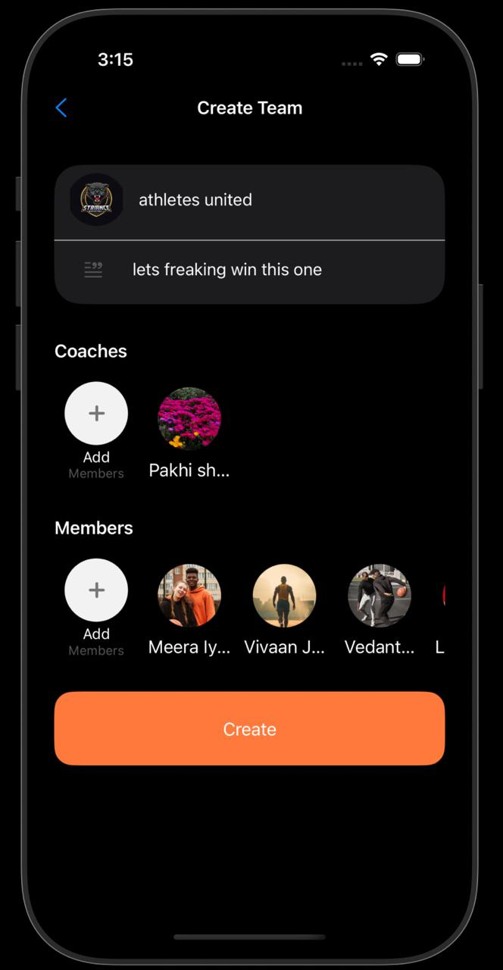
Figure.2.24:.Team.Creation.Interface

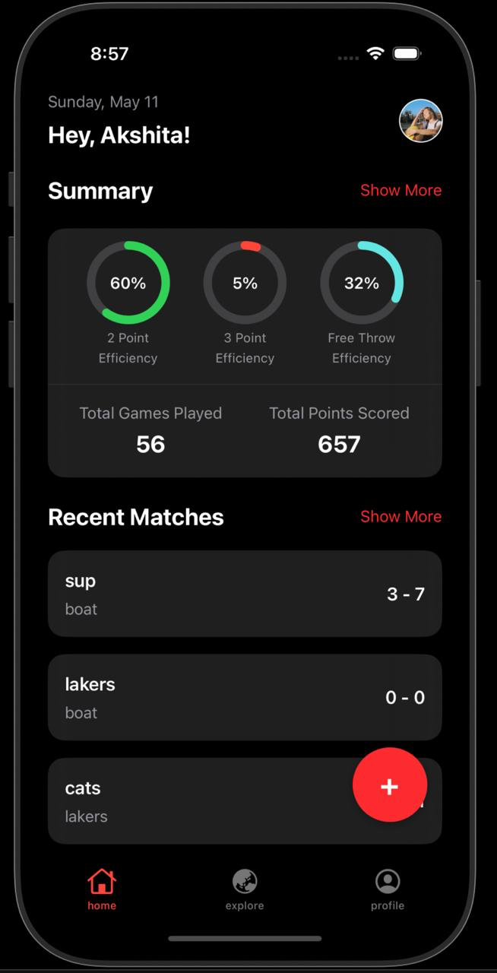
Figure 2.26: Athlete Dashboard
Figure 2.27: Team Profile Linking Interface

2.3.5 Functional Test Cases
Table 2.7: Functional Test Cases for Sprint 3
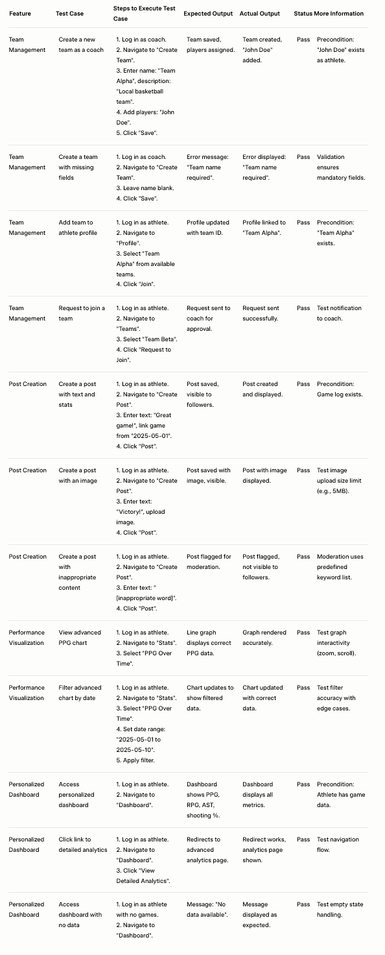
2.3.6 Daily Call Progress
A table summarizing daily standup outcomes:
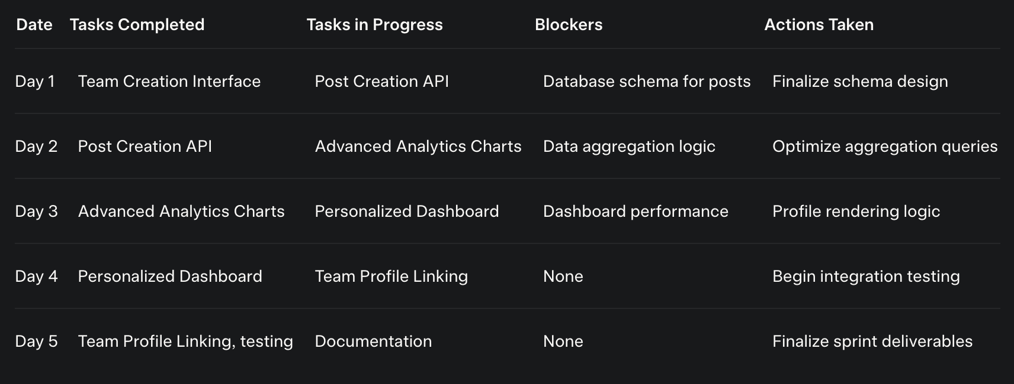
Figure 2.28: Daily Call Progress for Sprint 3
2.3.7 Committed Vs Completed User Stories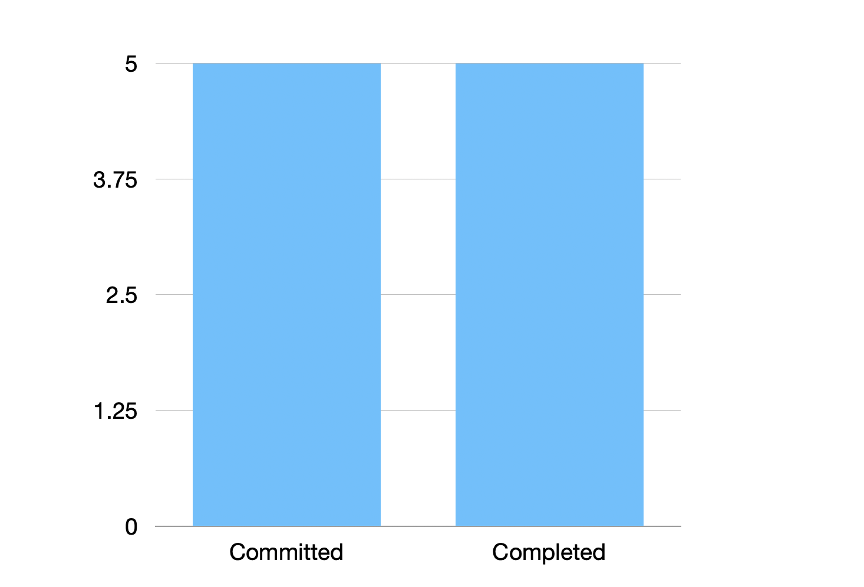Figure 2.29: Committed vs Completed User Stories for Sprint 3
A table comparing planned and completed user stories
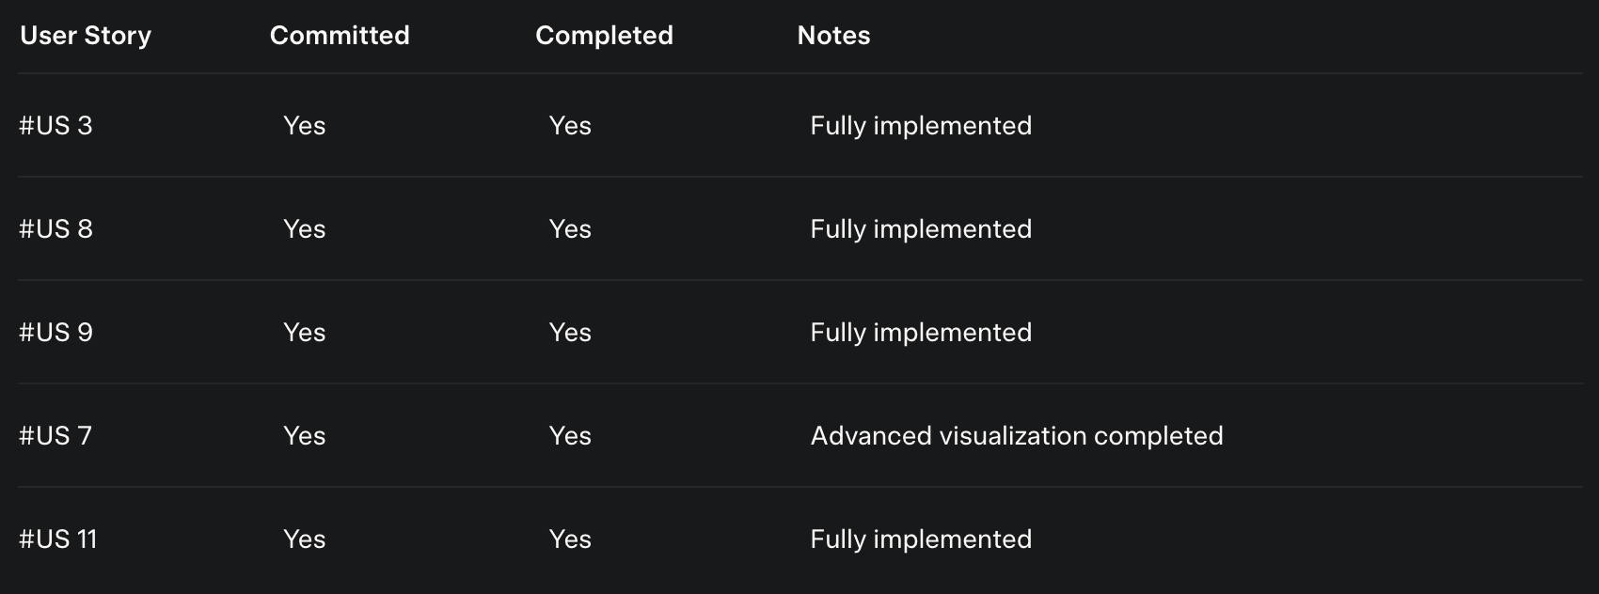
2.3.8 Sprint Retrospective
Content:
The Sprint 3 retrospective highlighted:
- What Went Well:
  - Successful implementation of team management and social features, completing the MVP.
  - Advanced analytics added significant value for athletes.
  - Improved team coordination reduced blockers.
- What Could Be Improved:
  - Dashboard performance on lower-end devices was slower than expected.
  - Post creation UI could be more intuitive for first-time users.
- Action Items:
  - Optimize dashboard rendering for better performance.
  - Conduct user testing for post creation to improve UX.
  - Document lessons learned for future sprints or iterations.

